First game: Worldbound

Rules for Worldbound
Game rules: These are my first rules I made for my game.
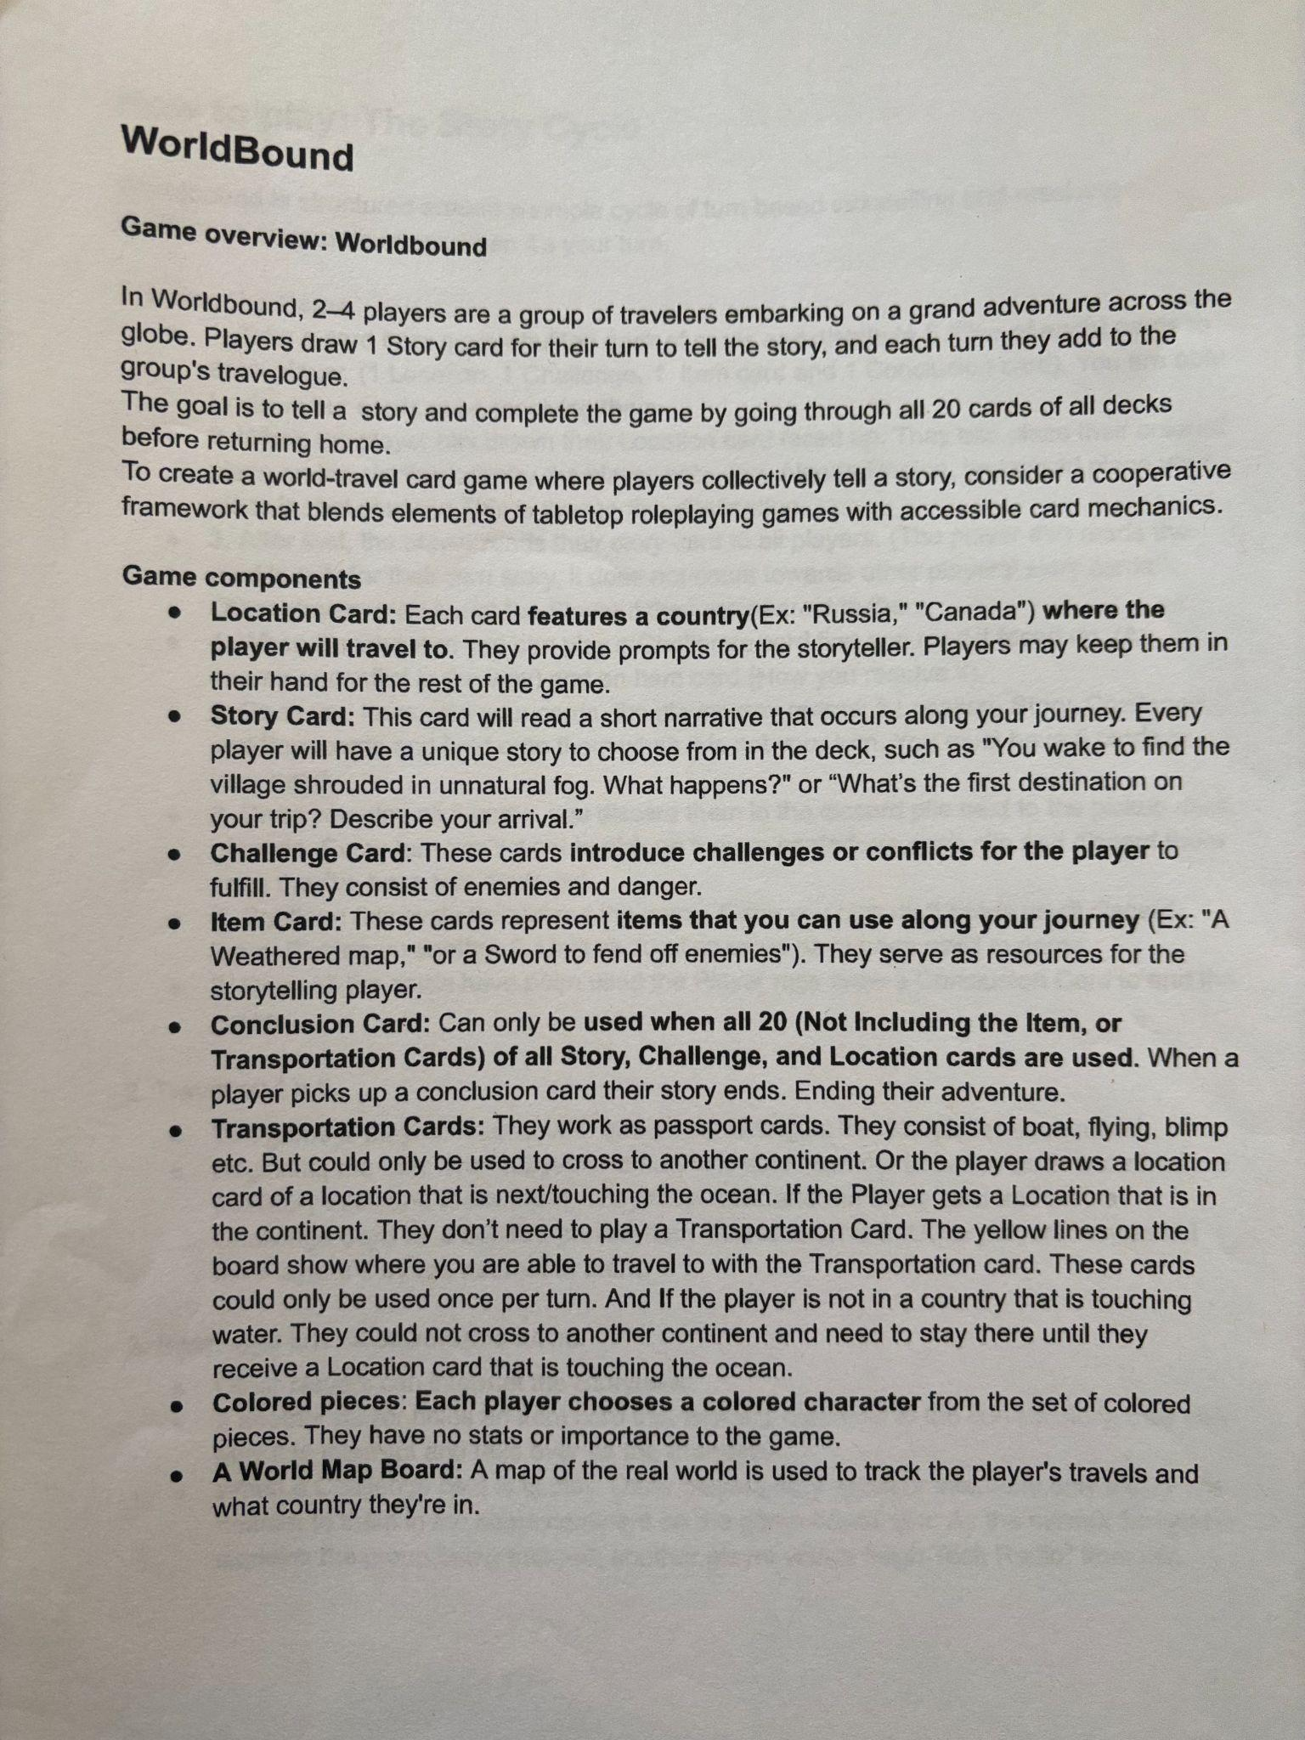
Photos of Notes/Play tests/Inspiration:
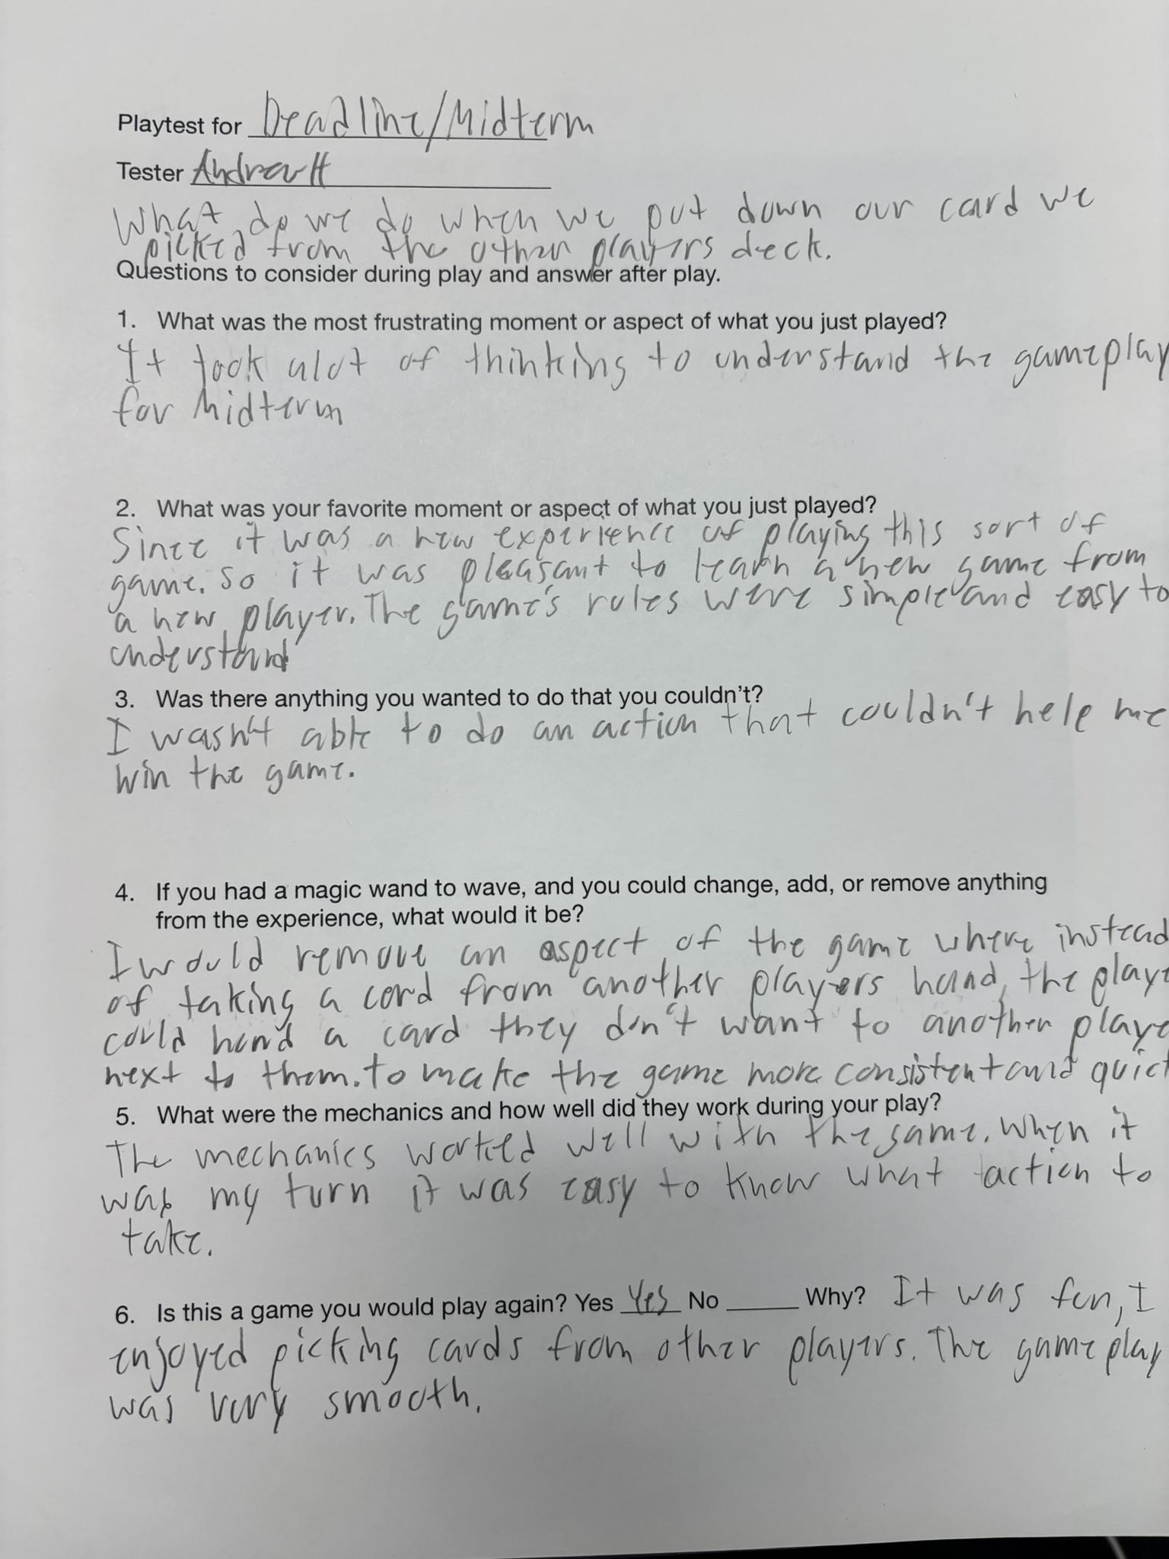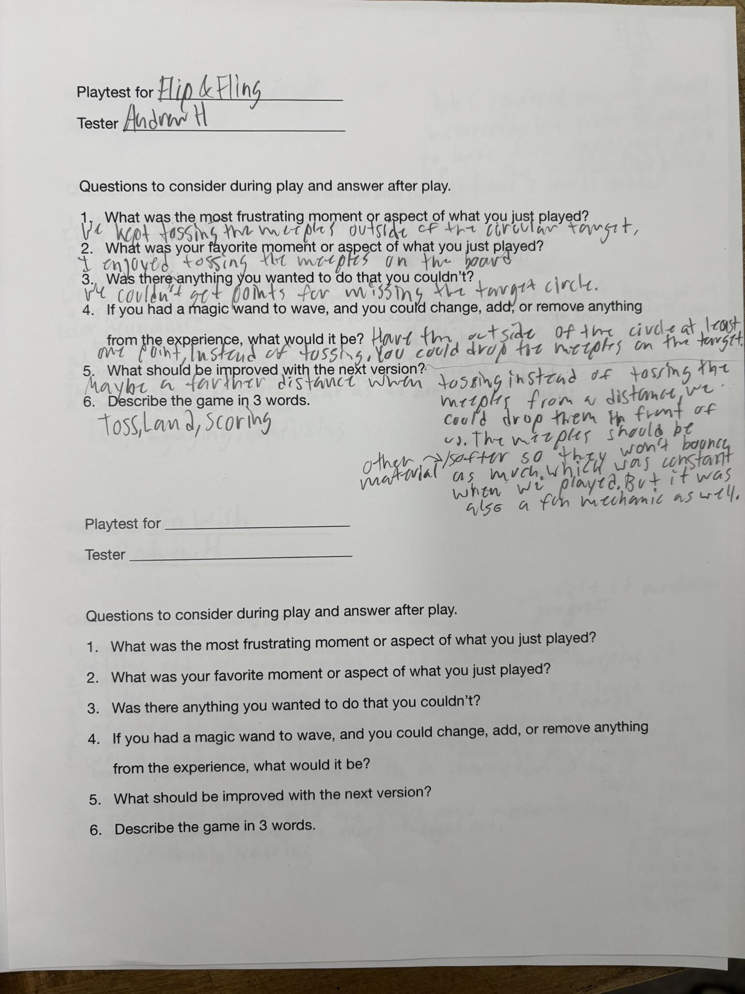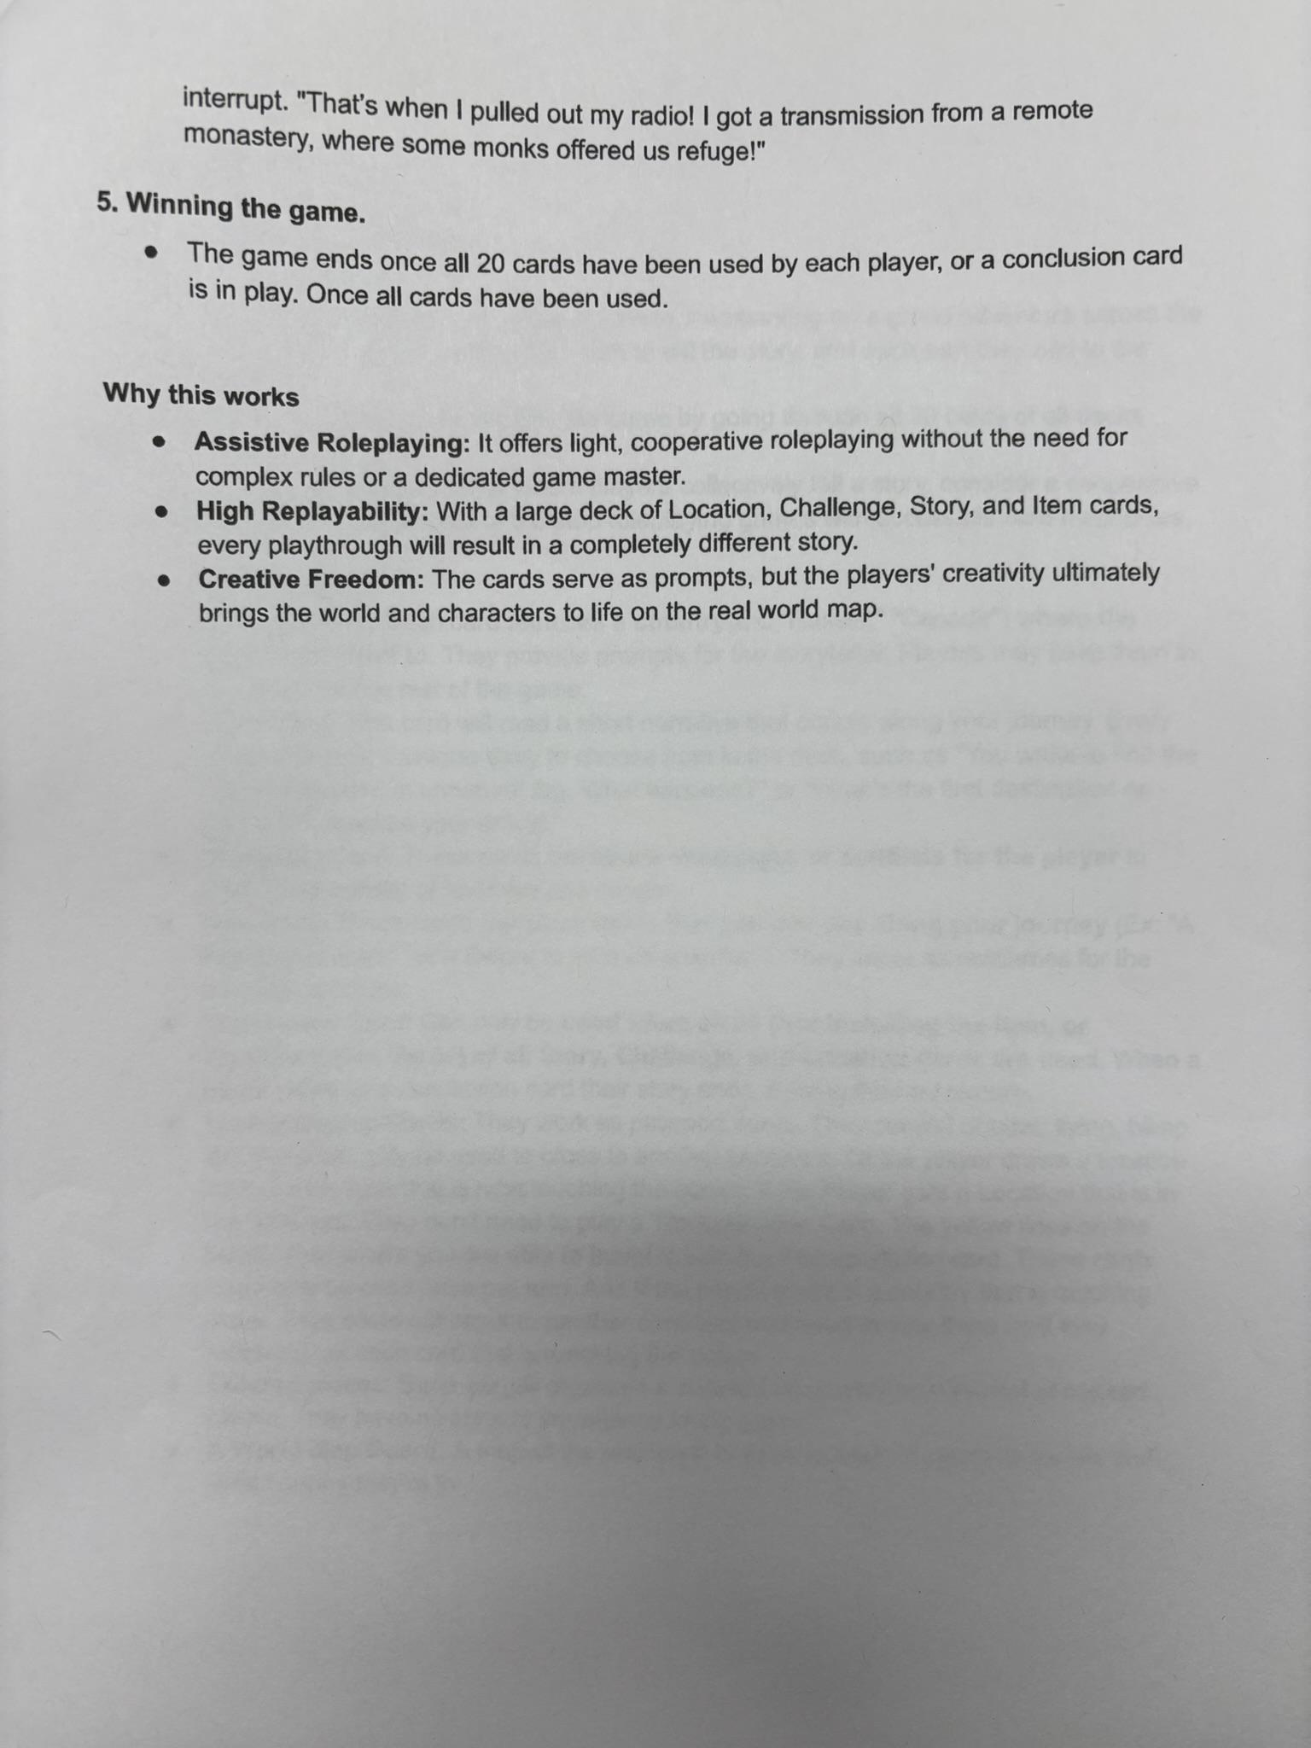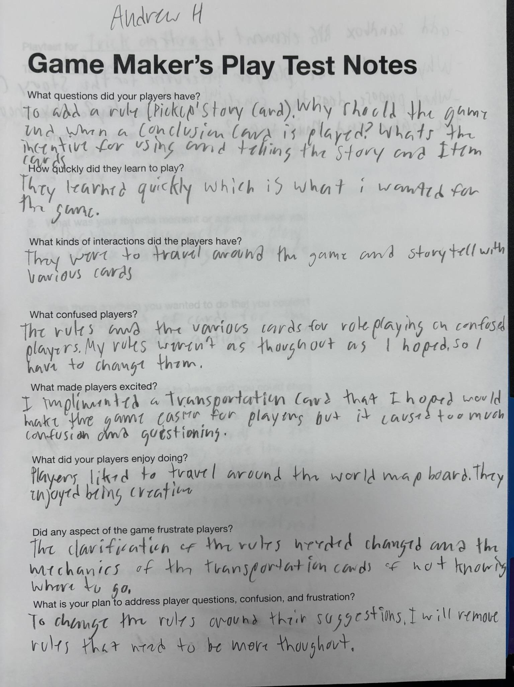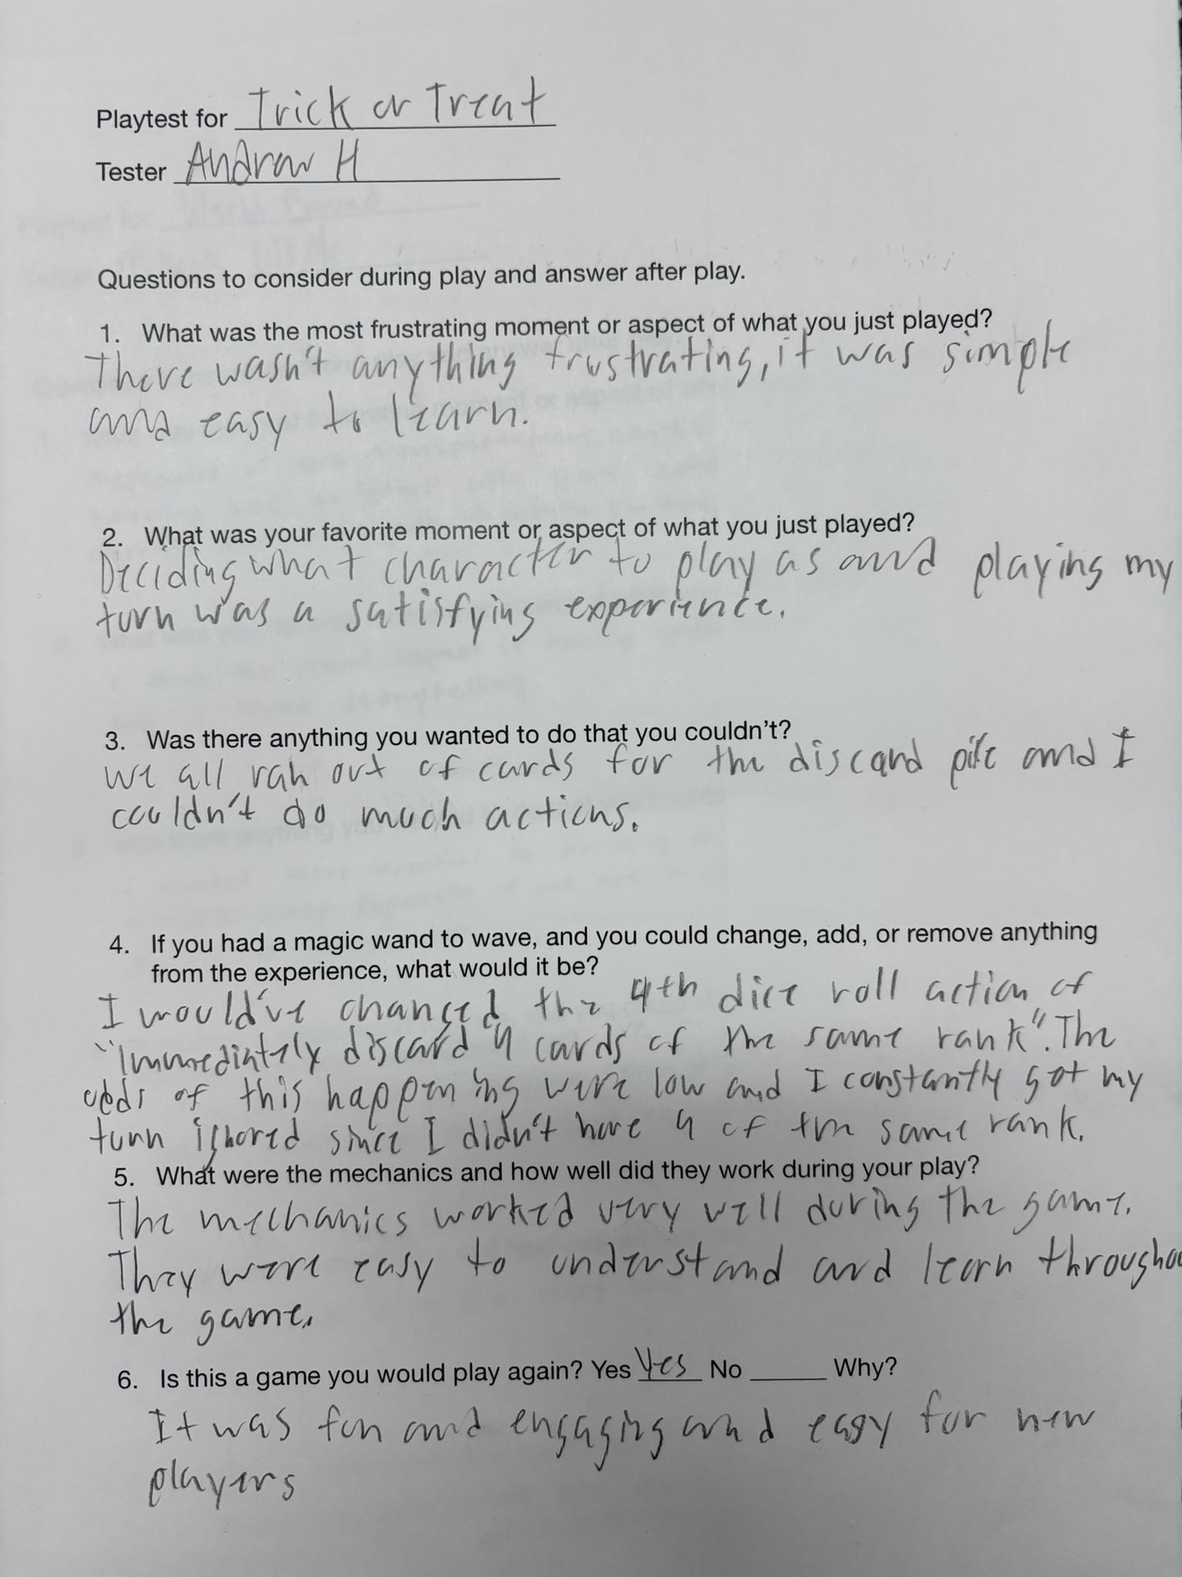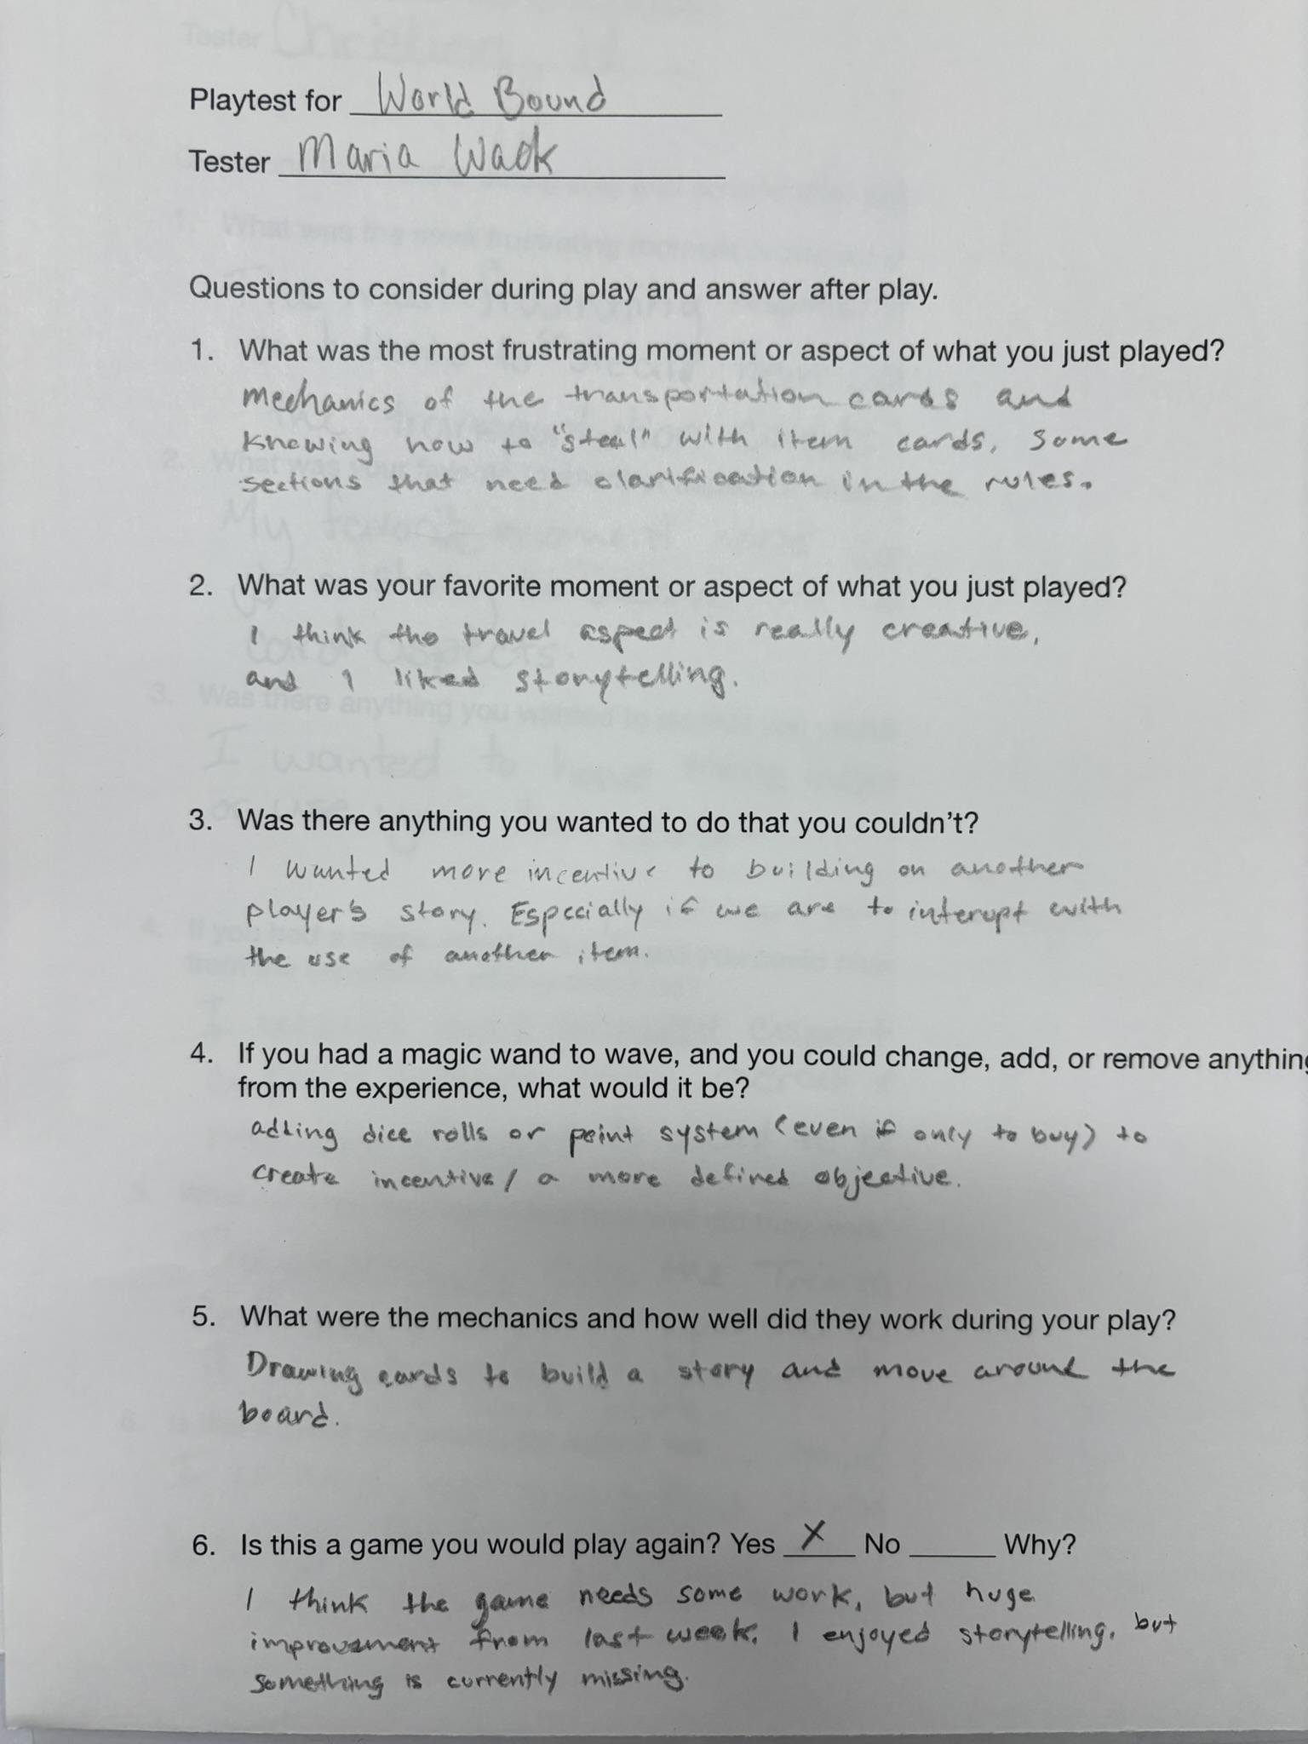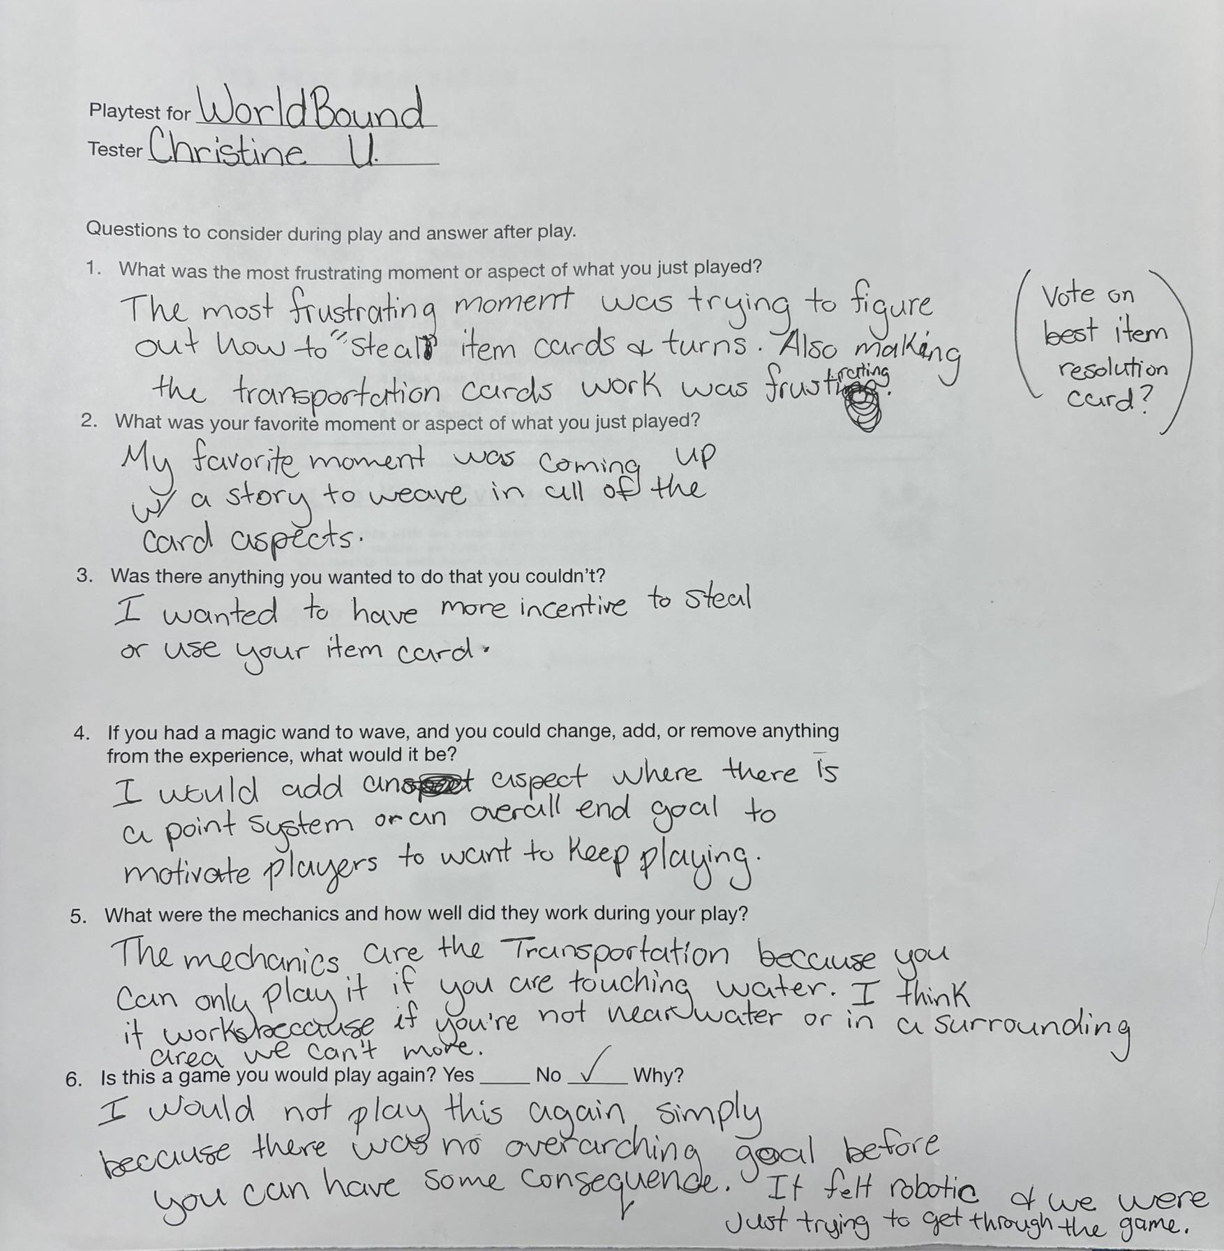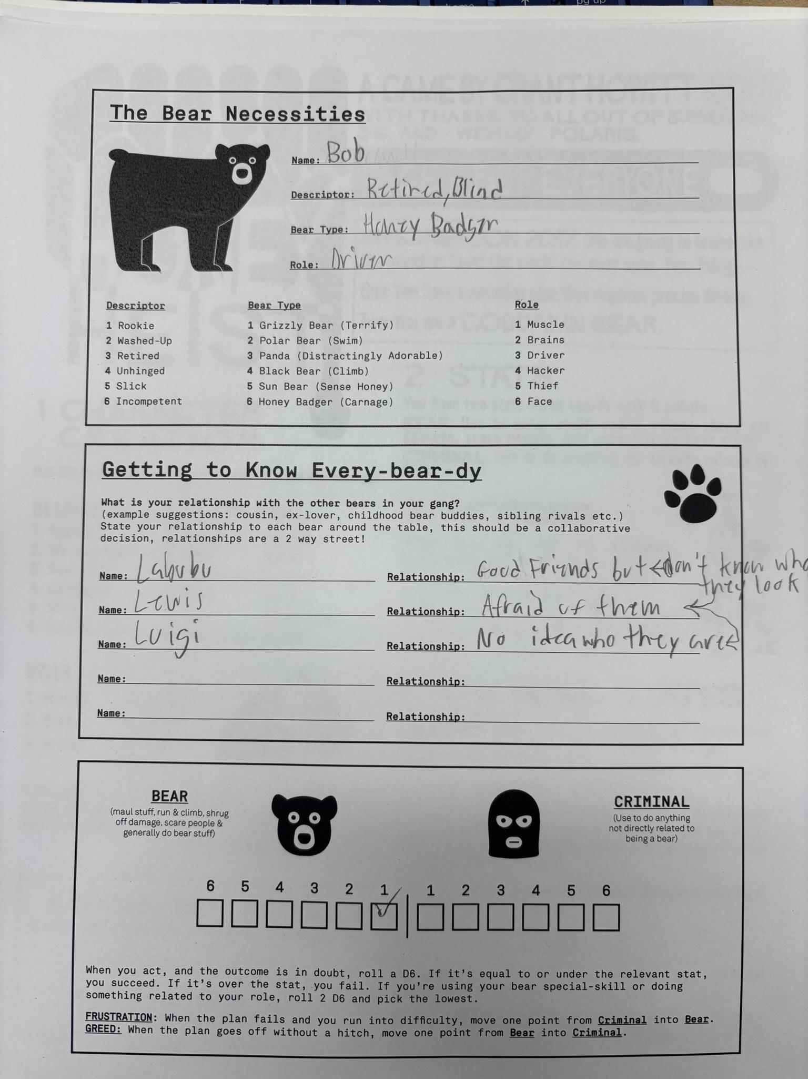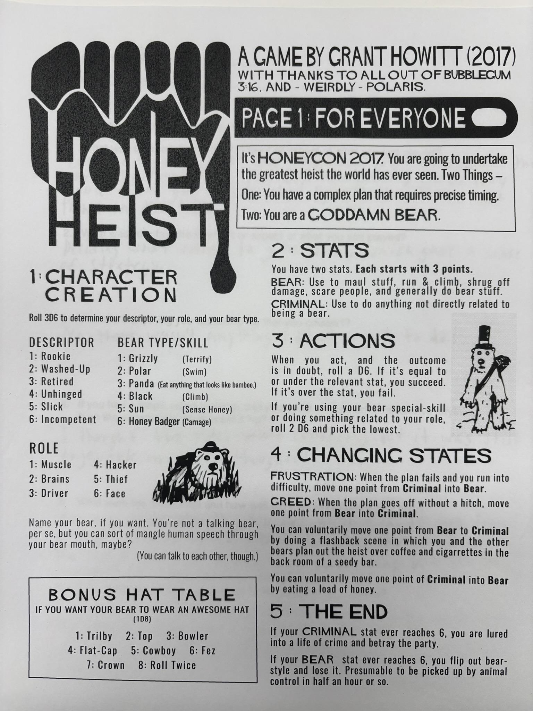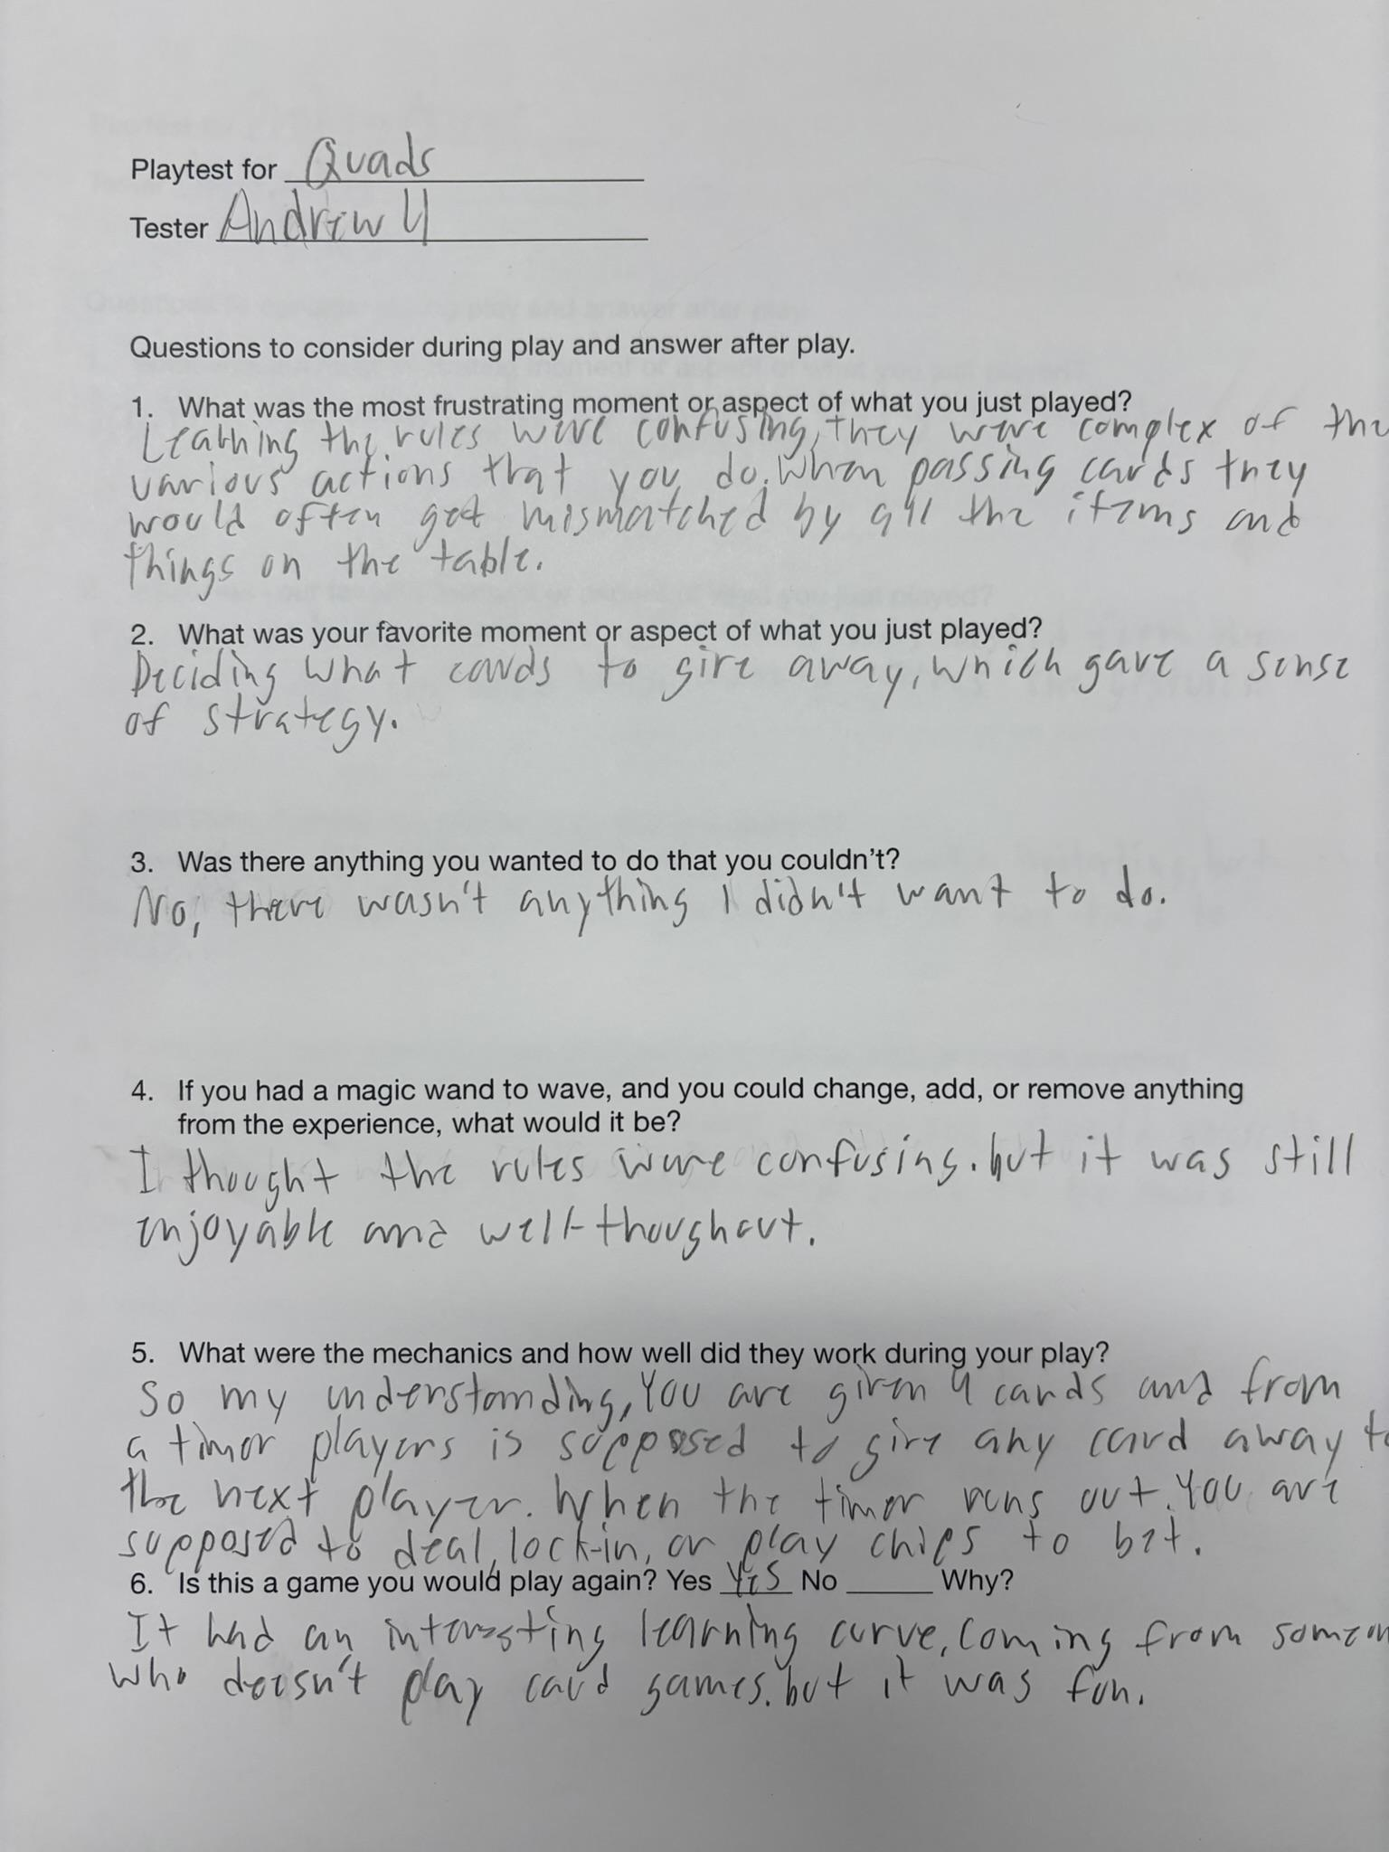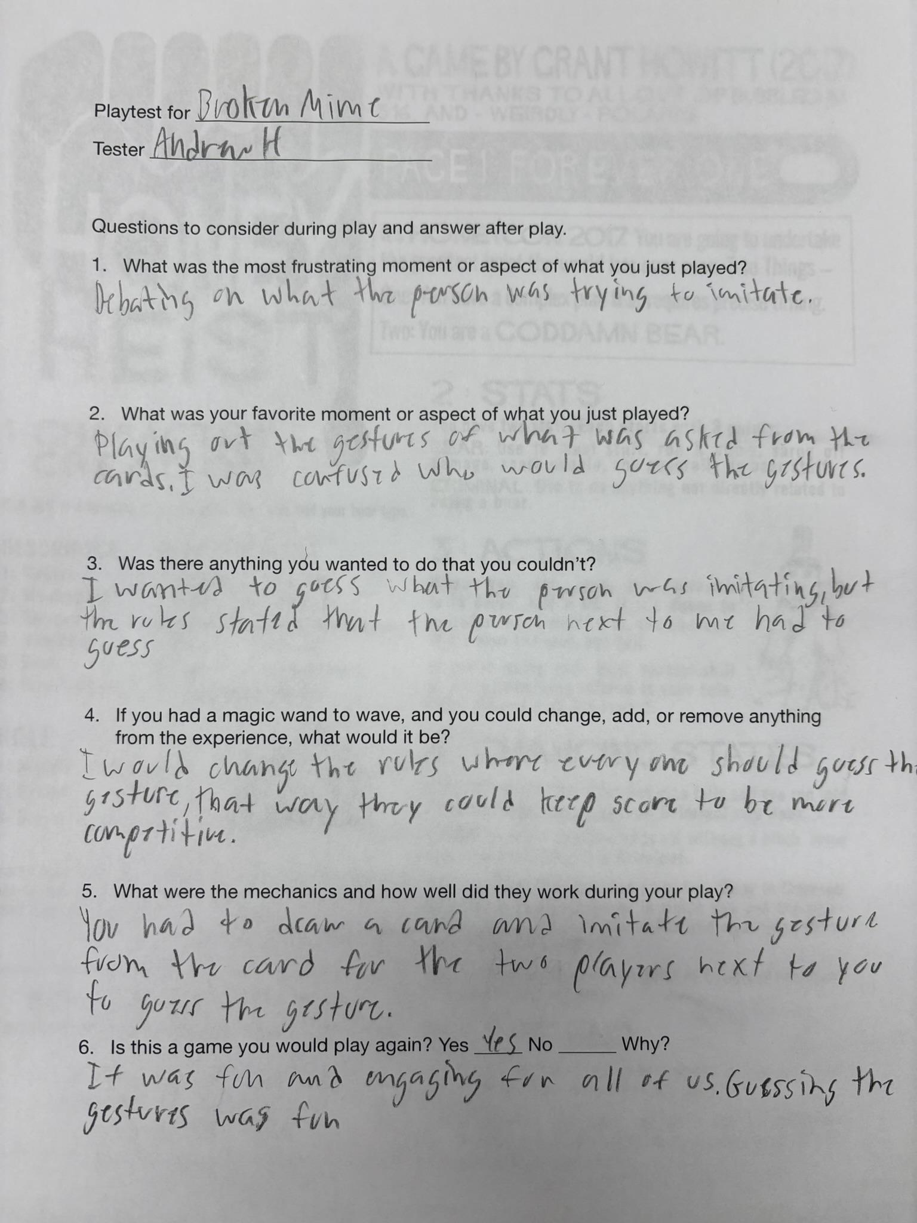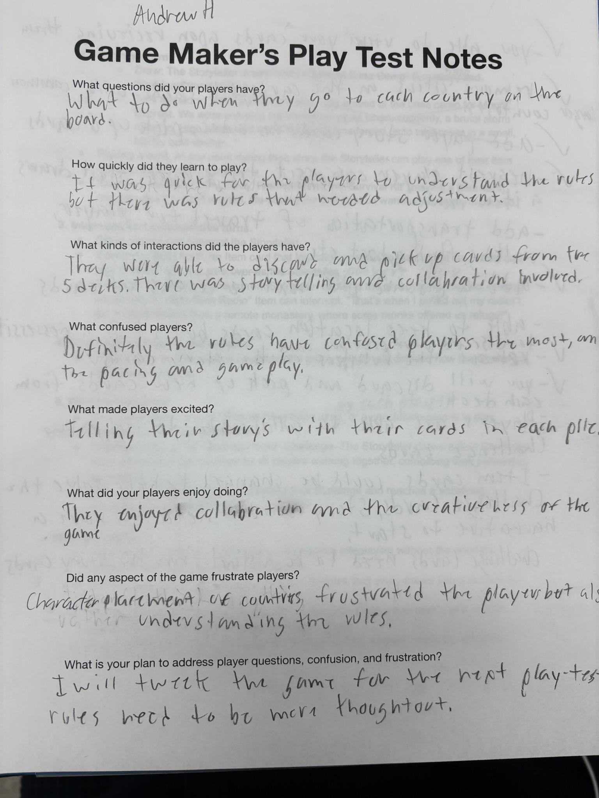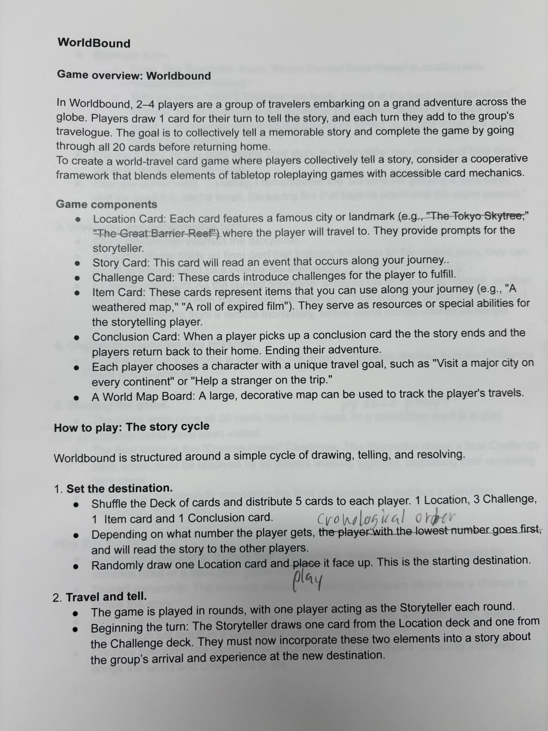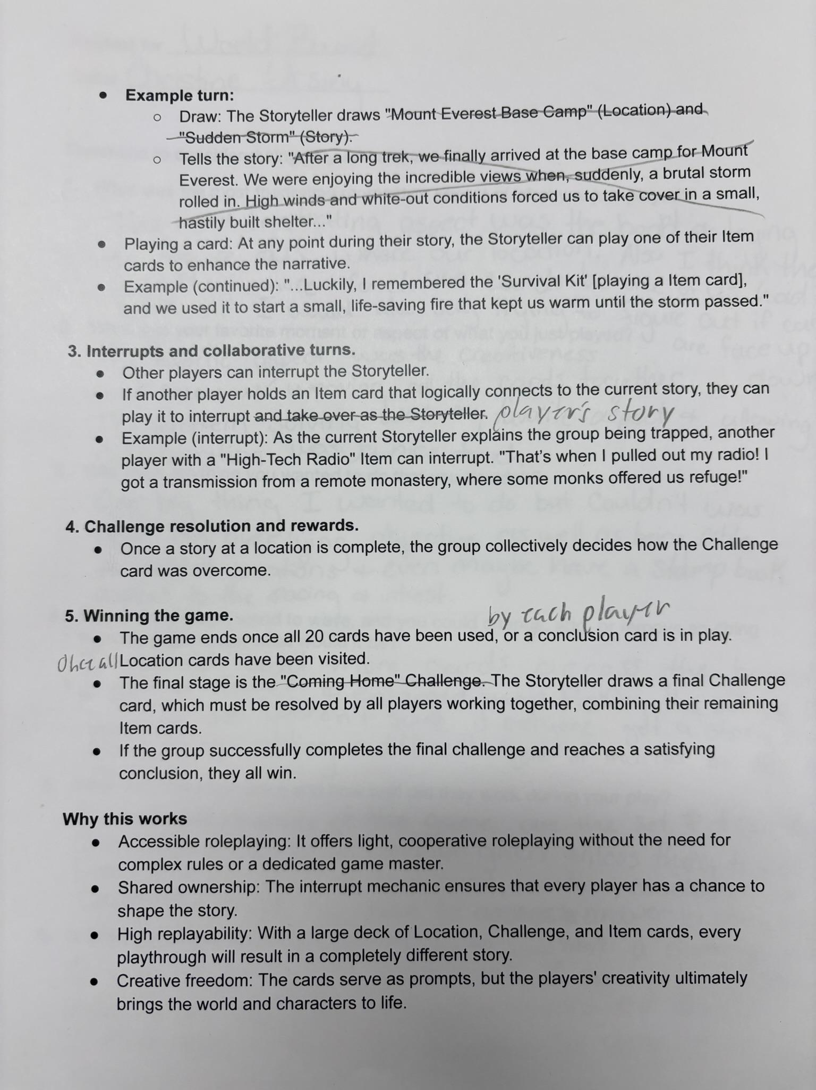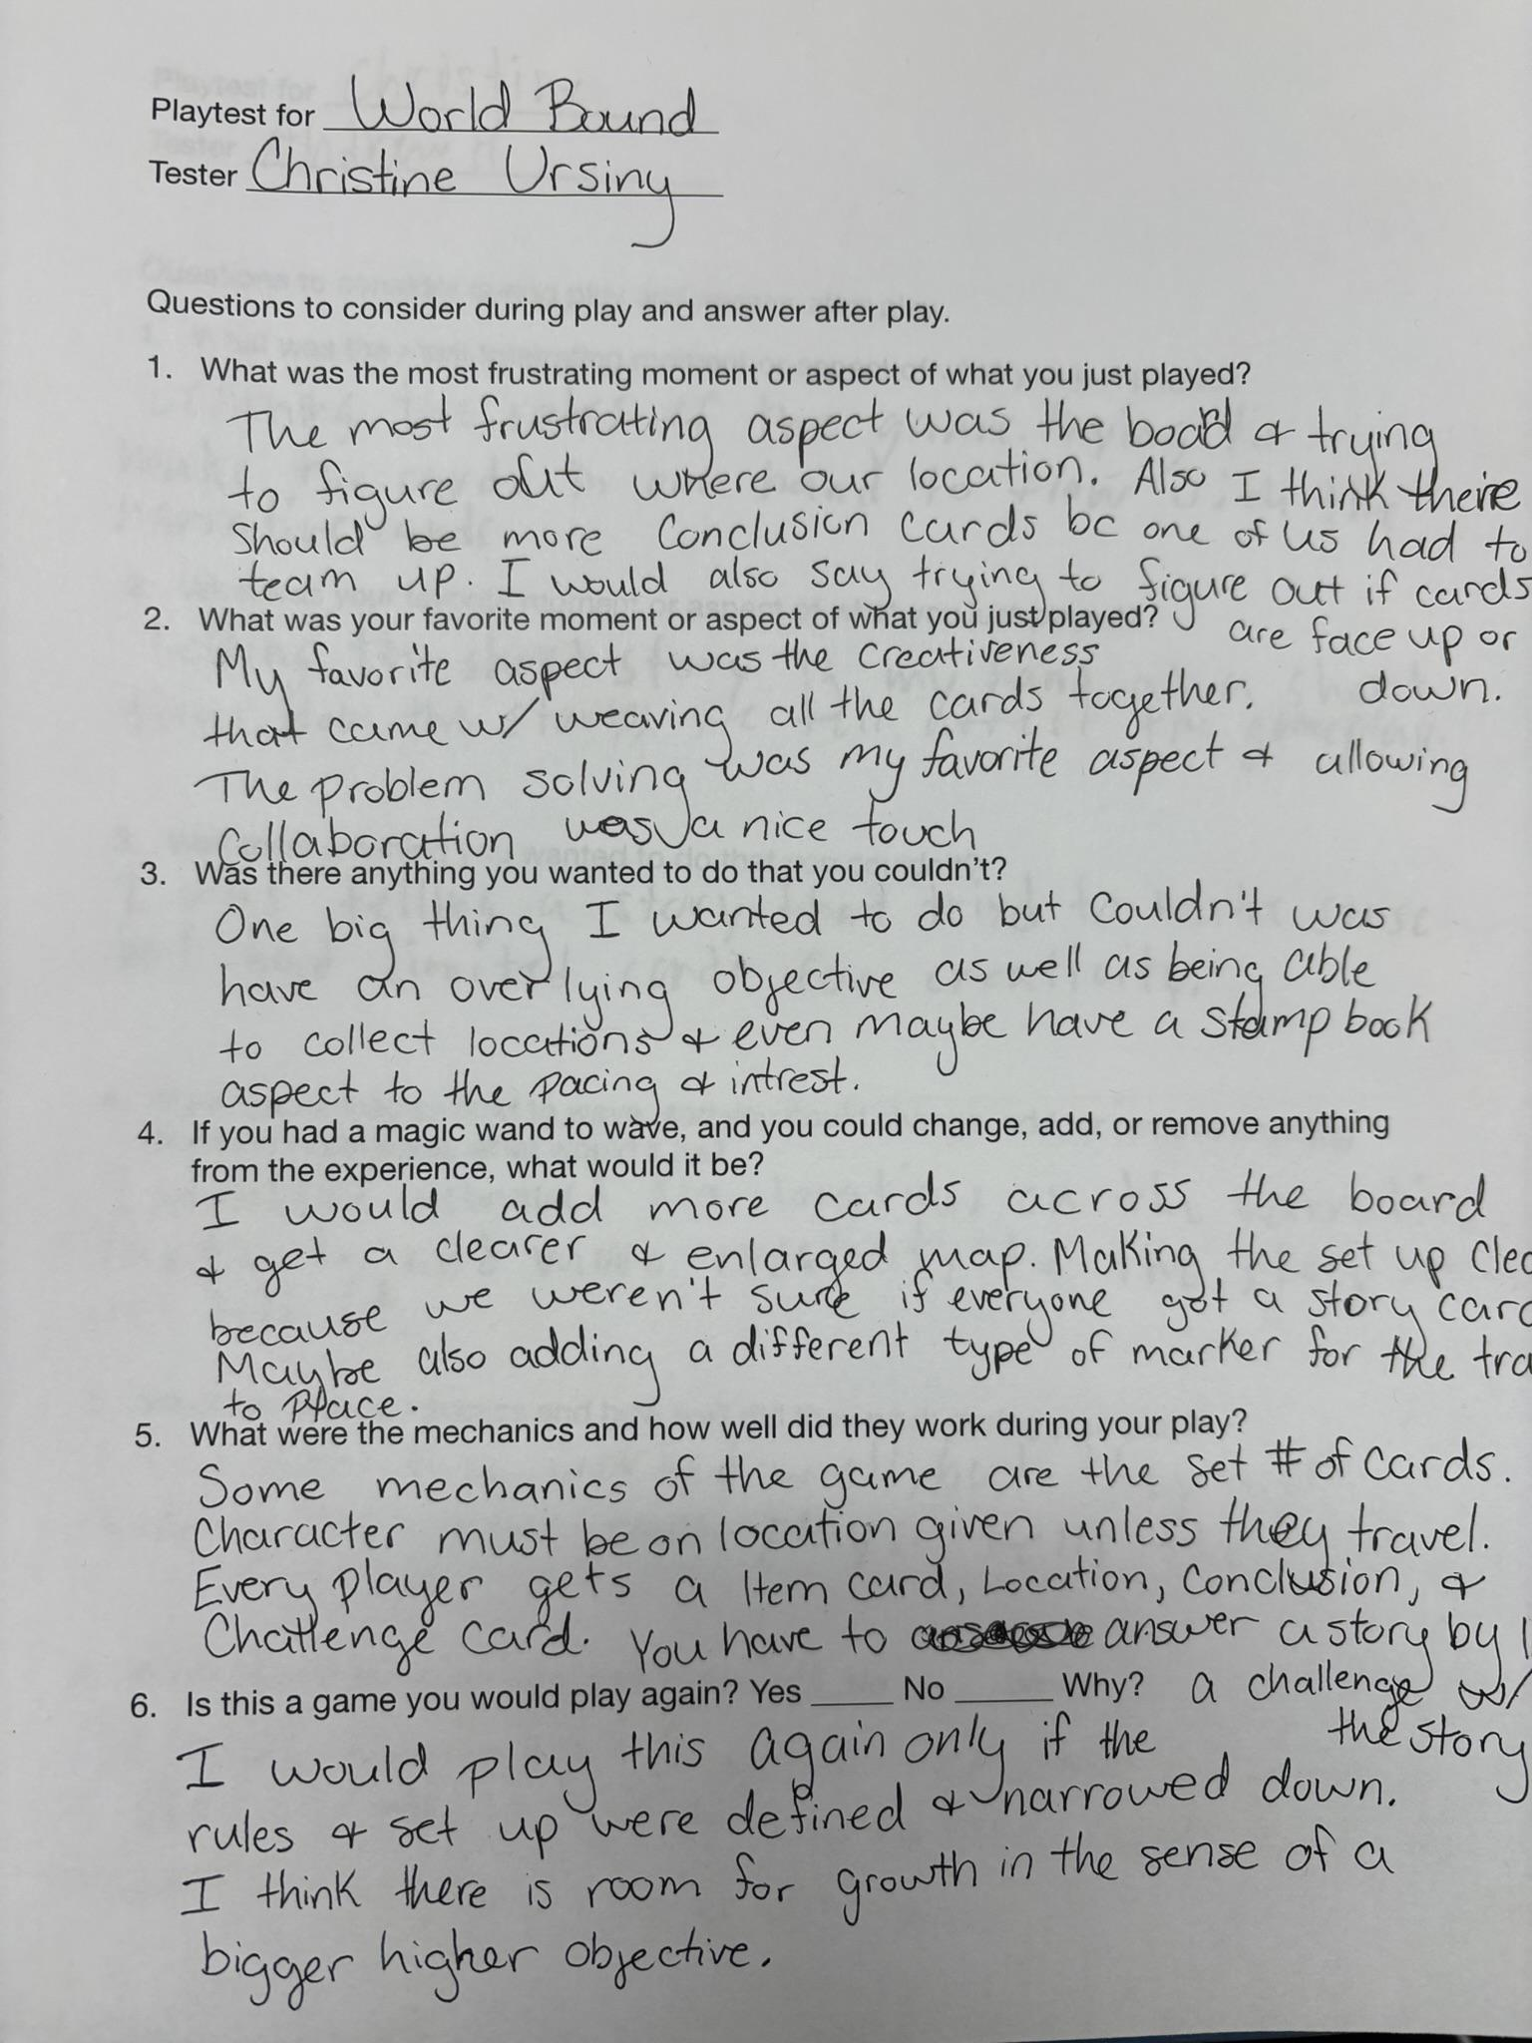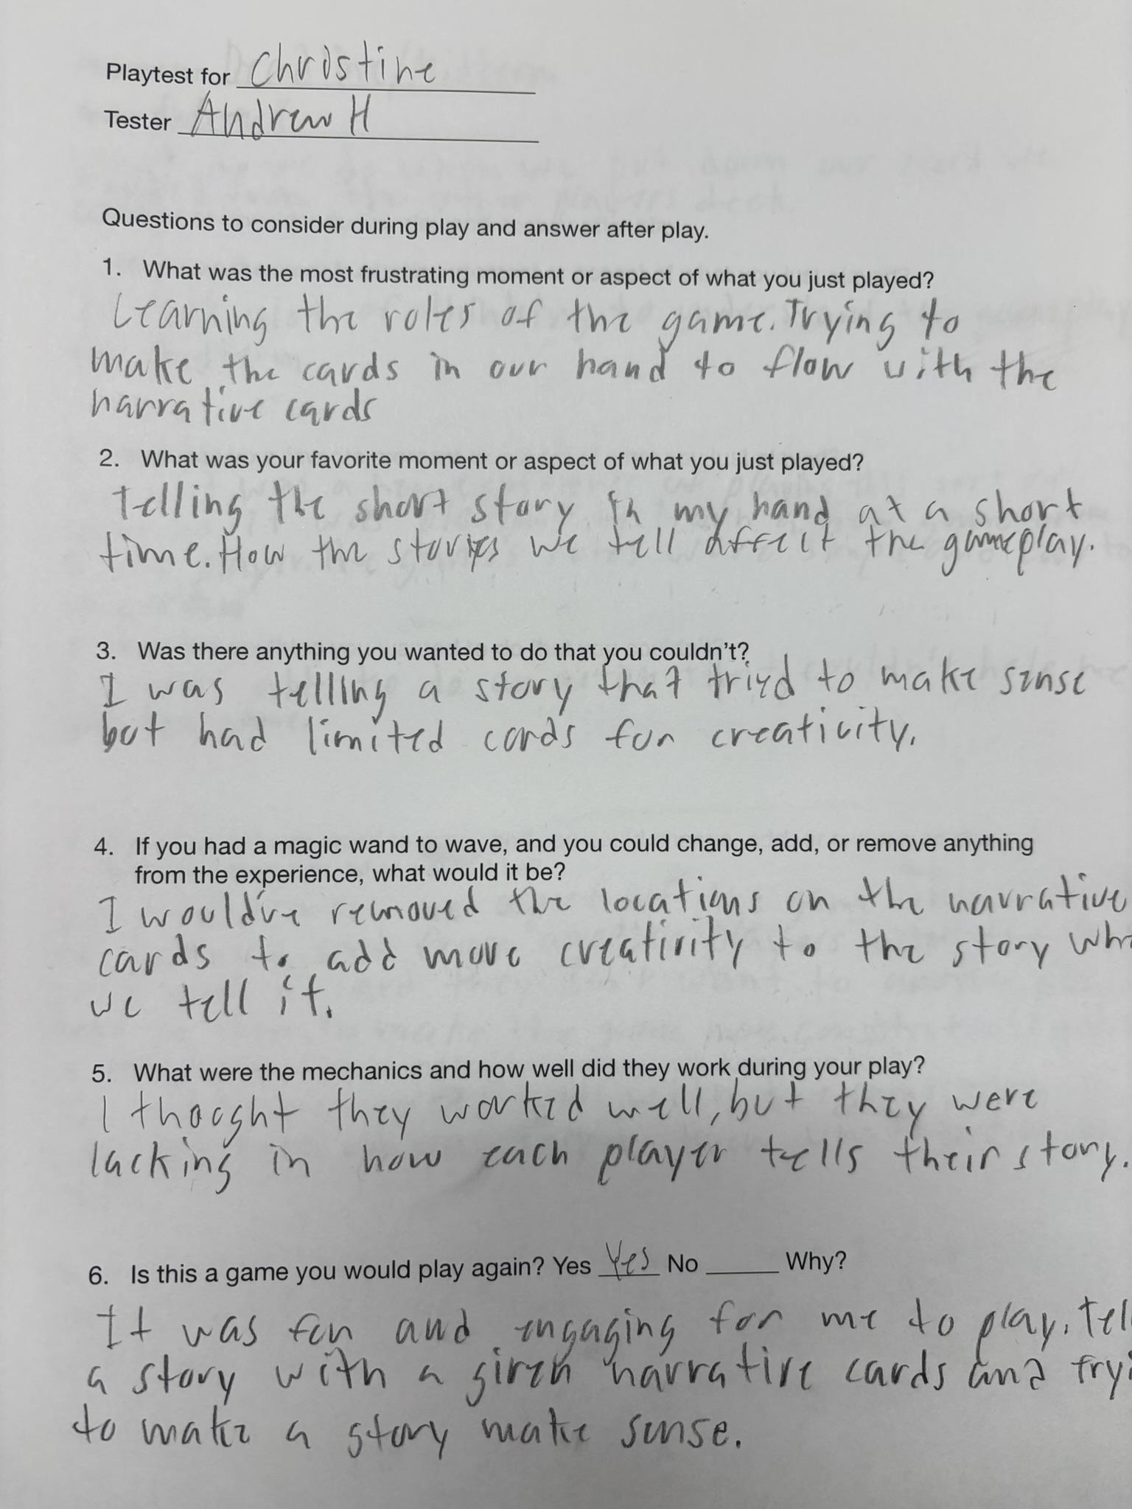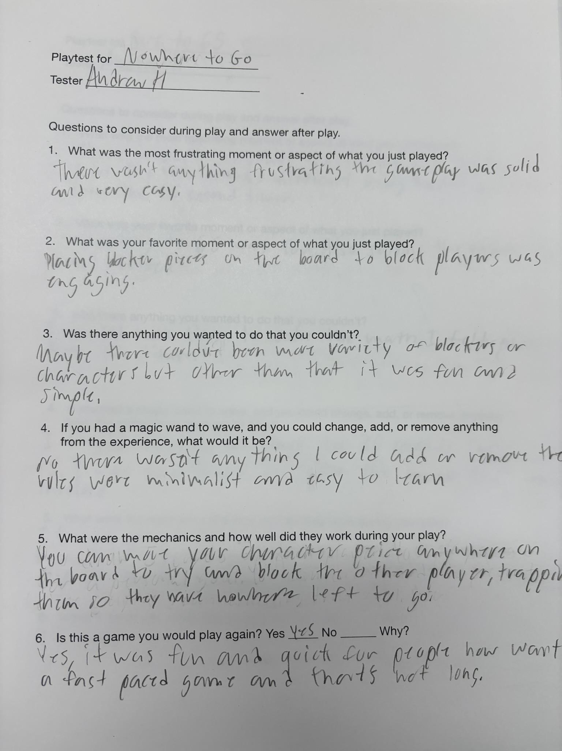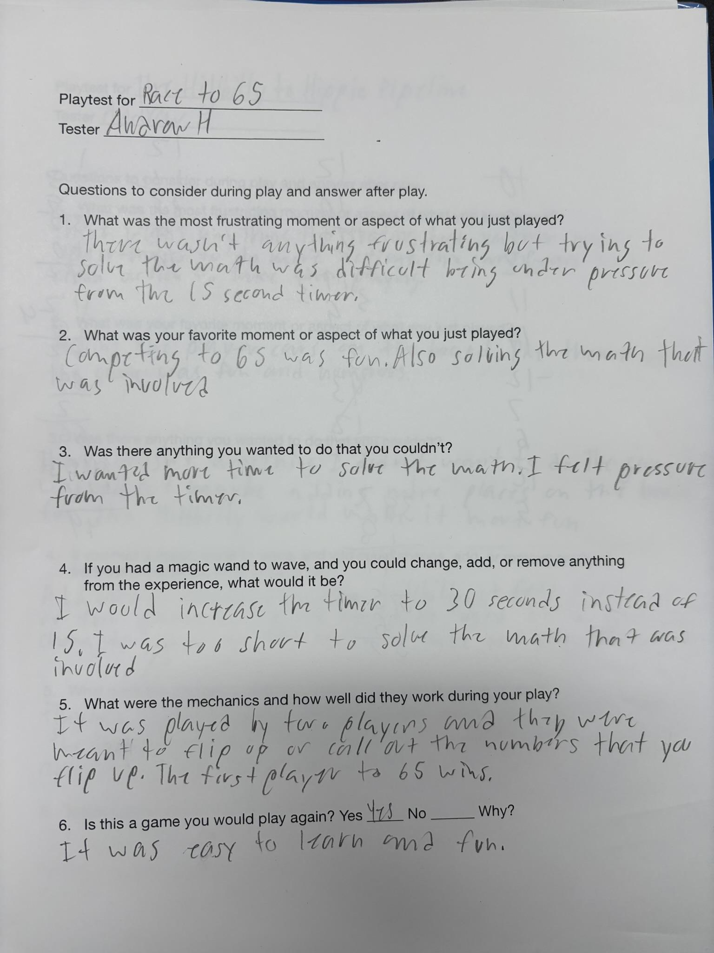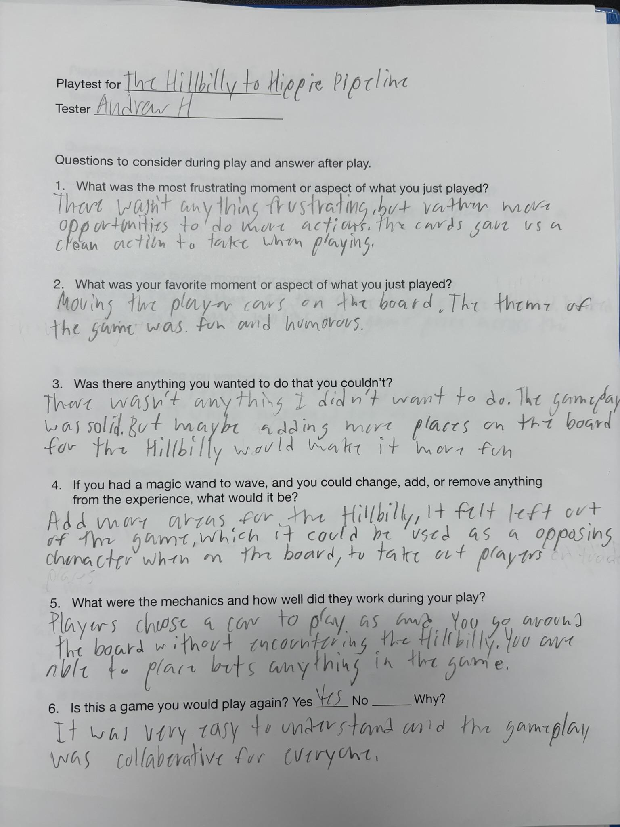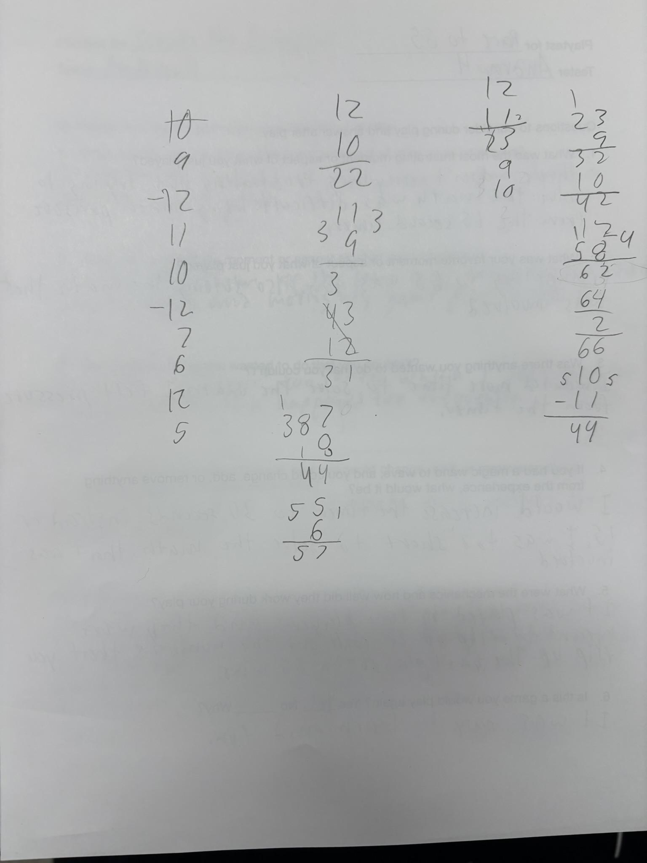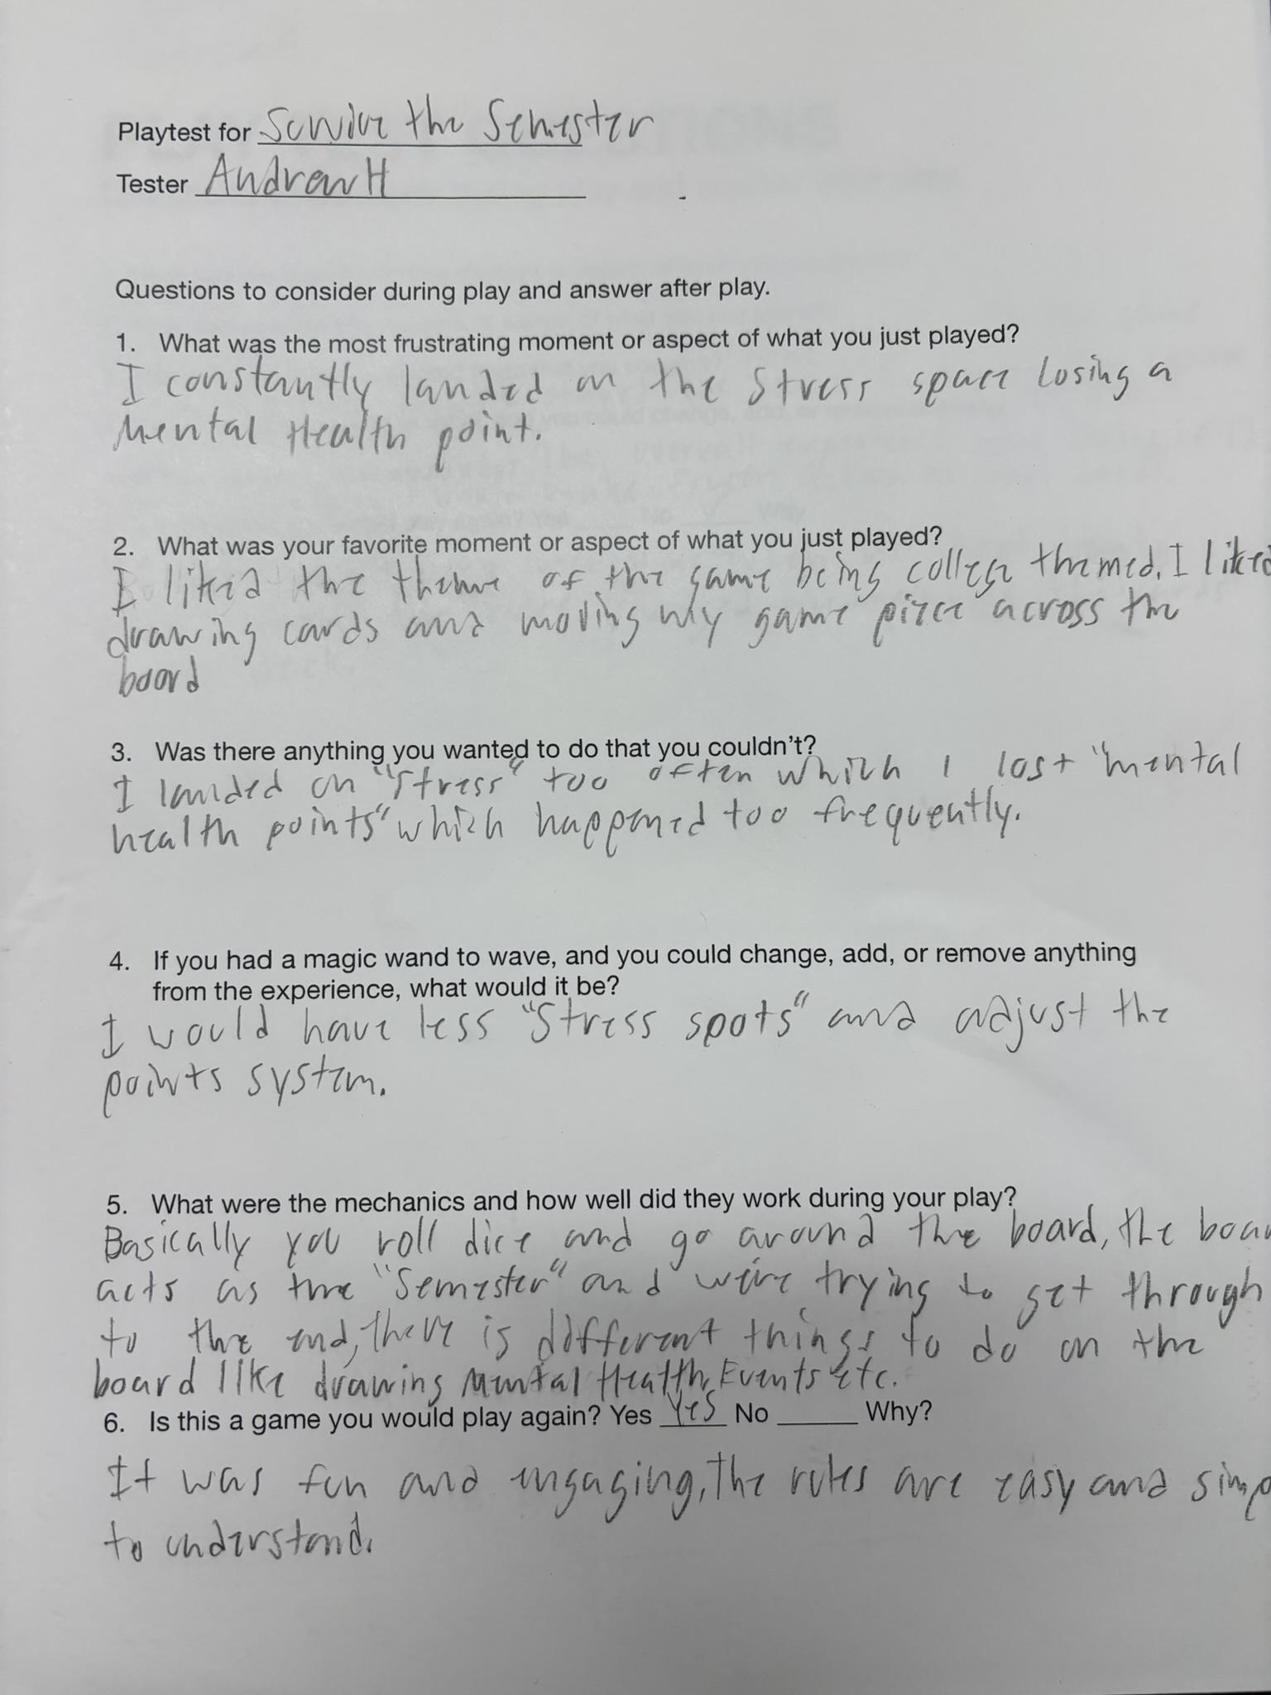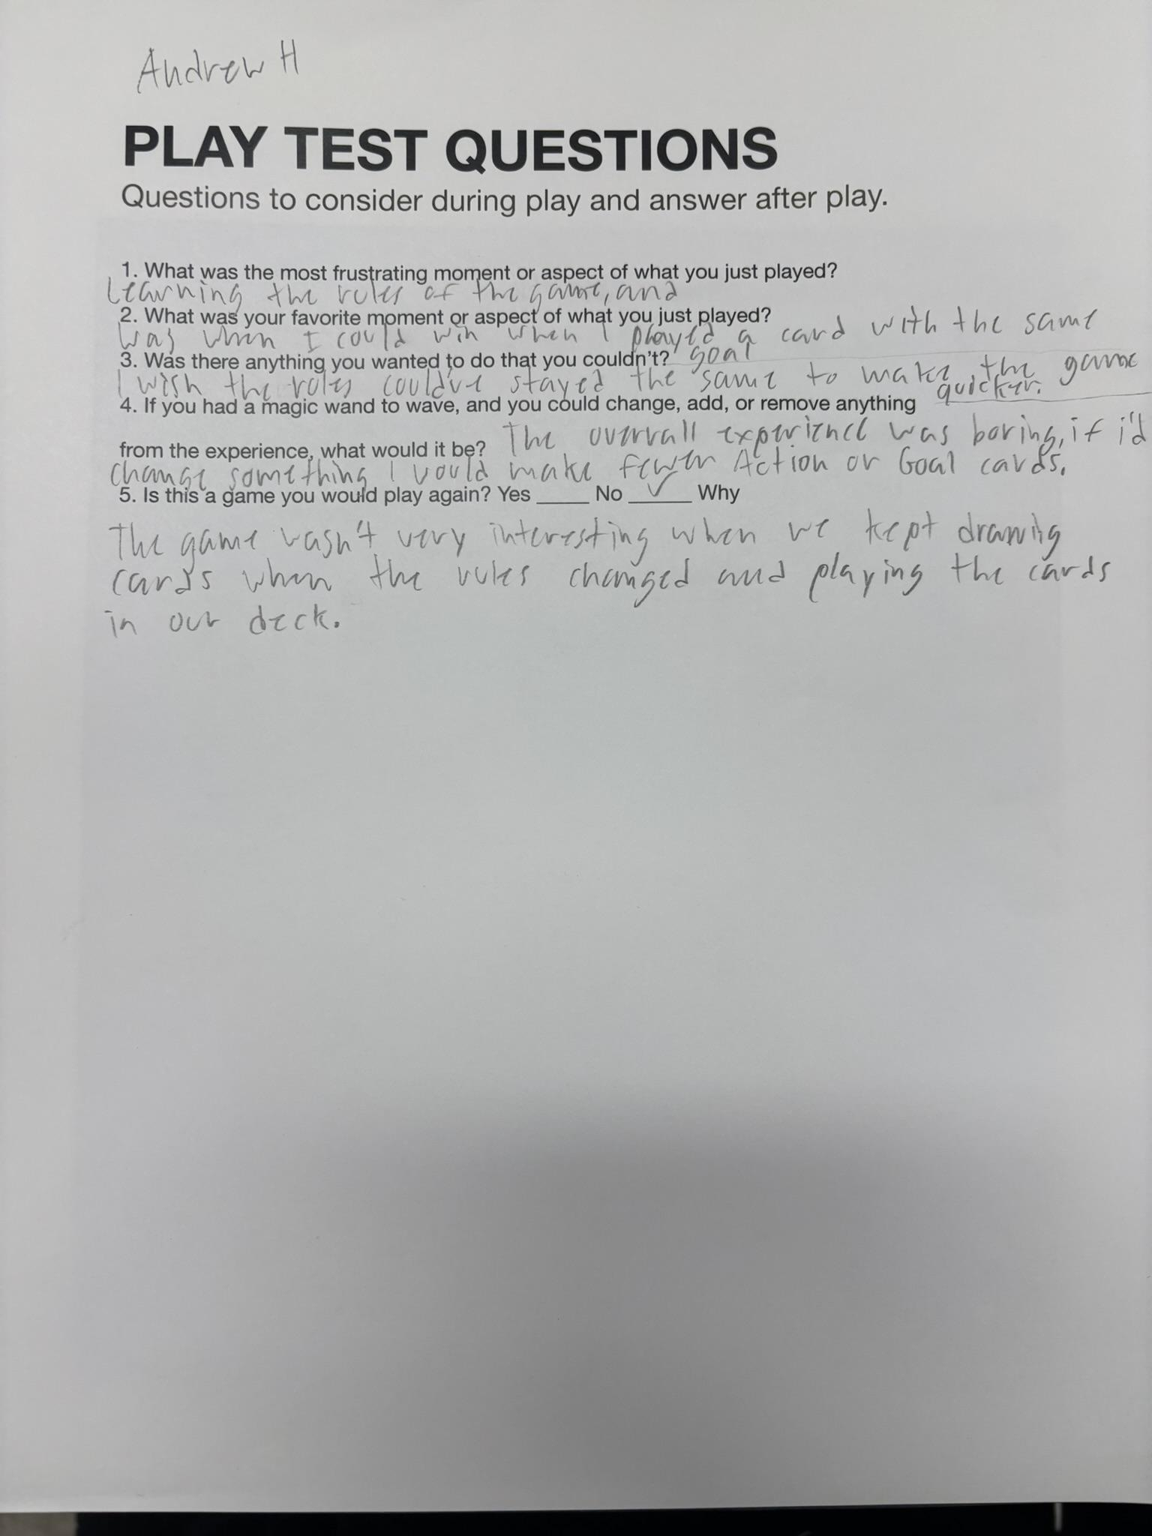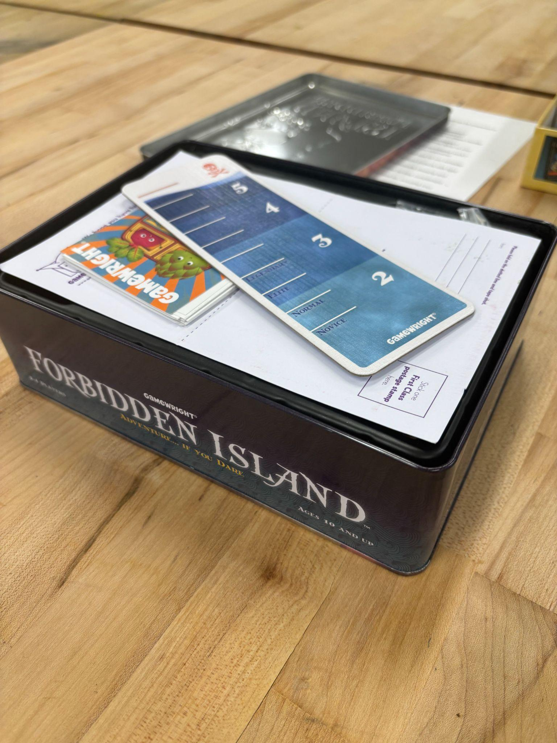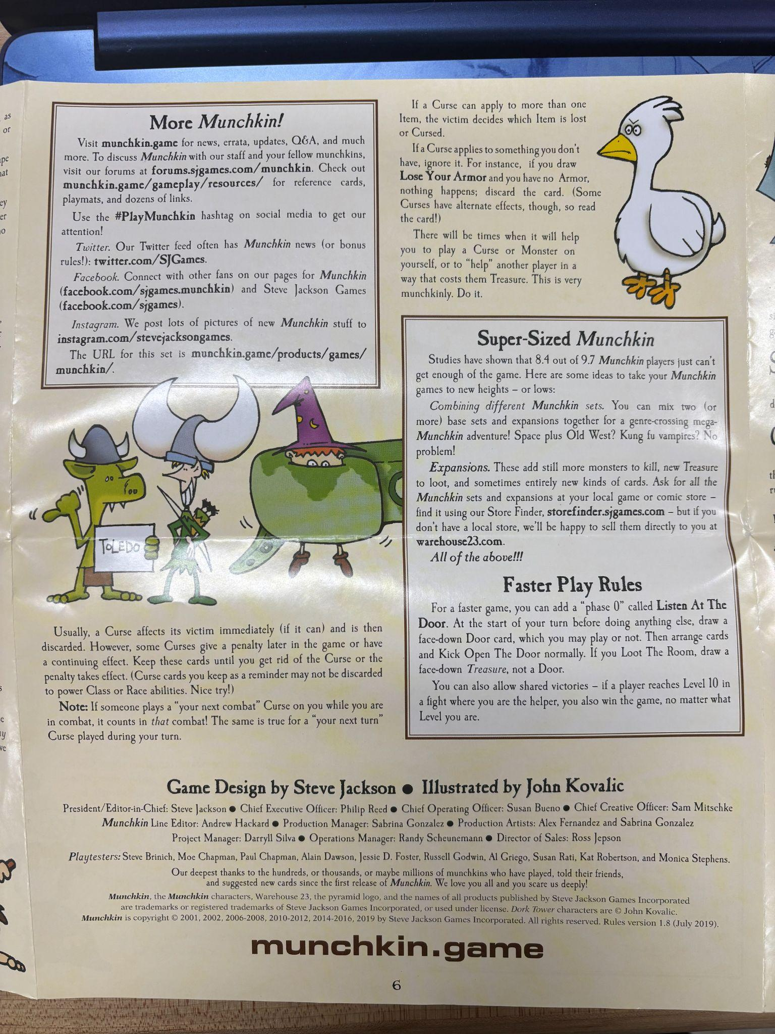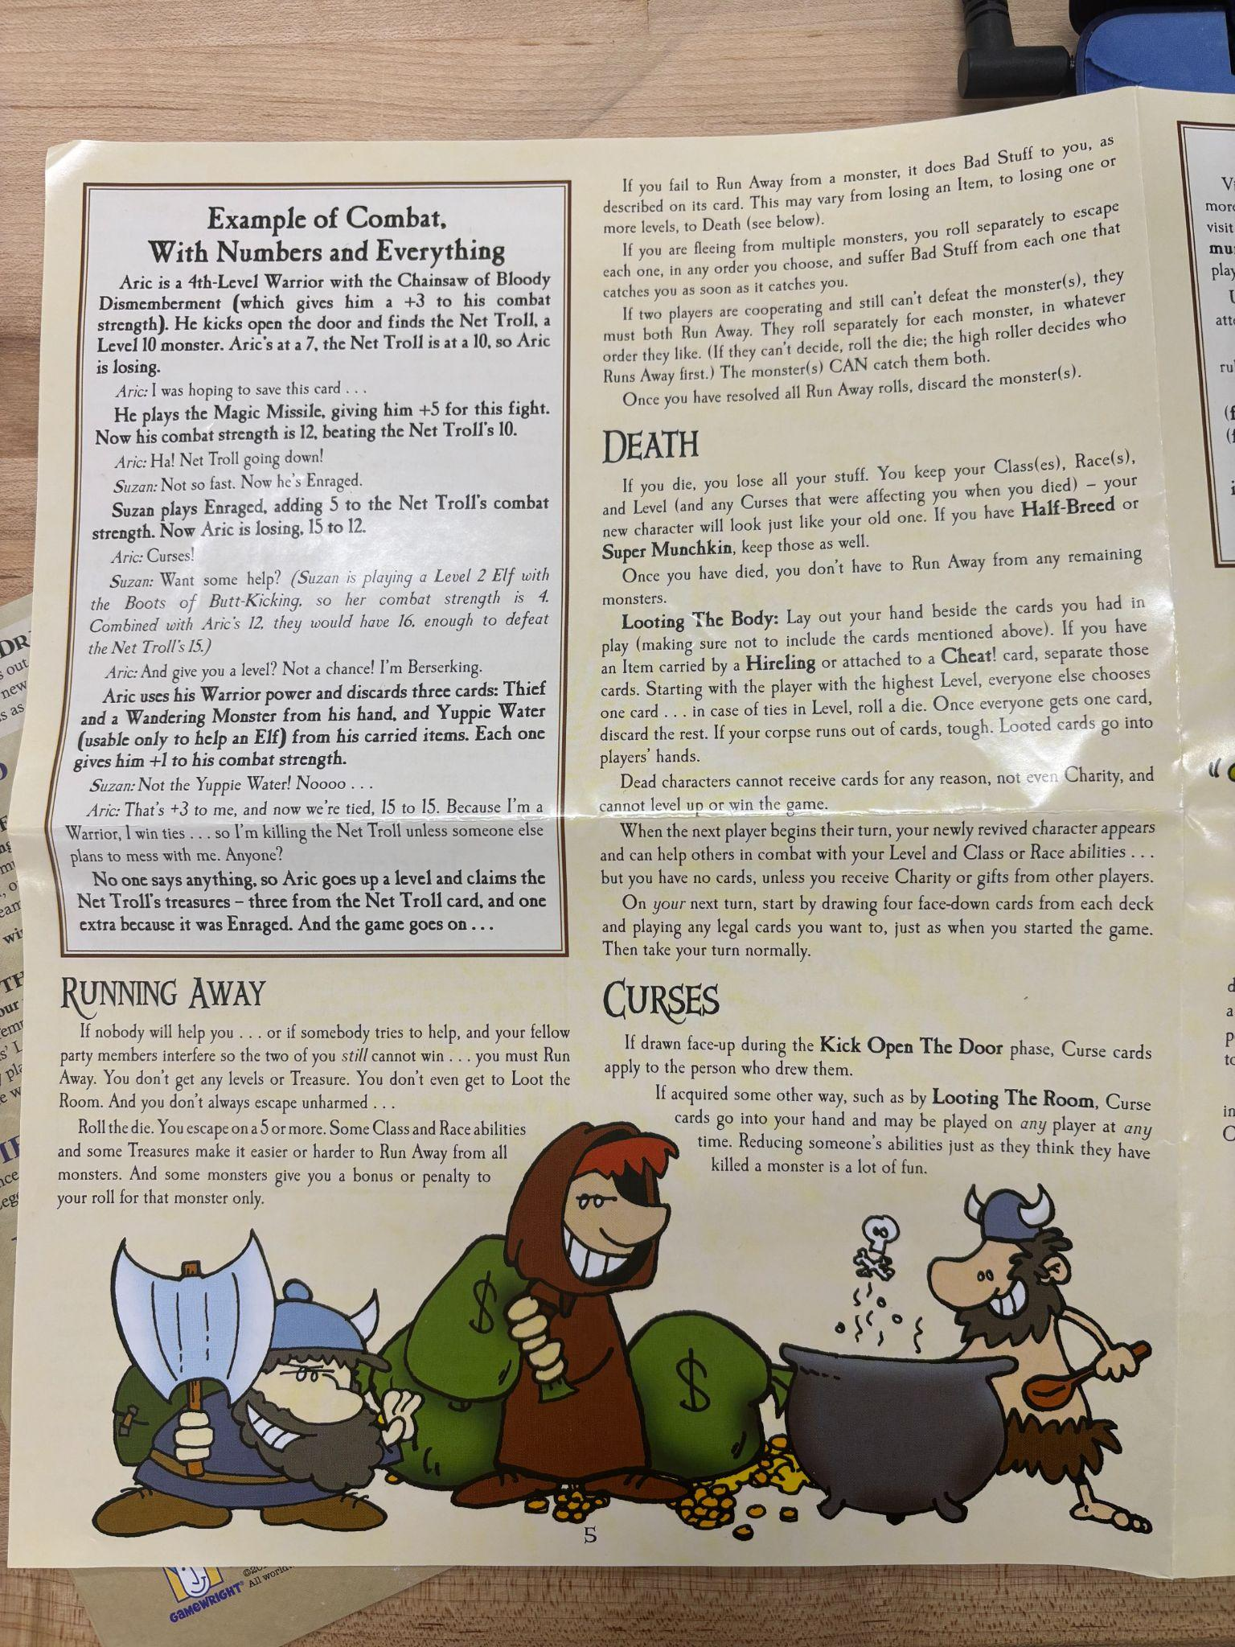

The game when setup
These are the first pieces I made, the Story cards originally had numbers on them to indicate the player with the lowest number would go first. But this didn’t work out during the play testing of the game. So in my next refinement I removed the story cards and re-thought about the use of them during the game.
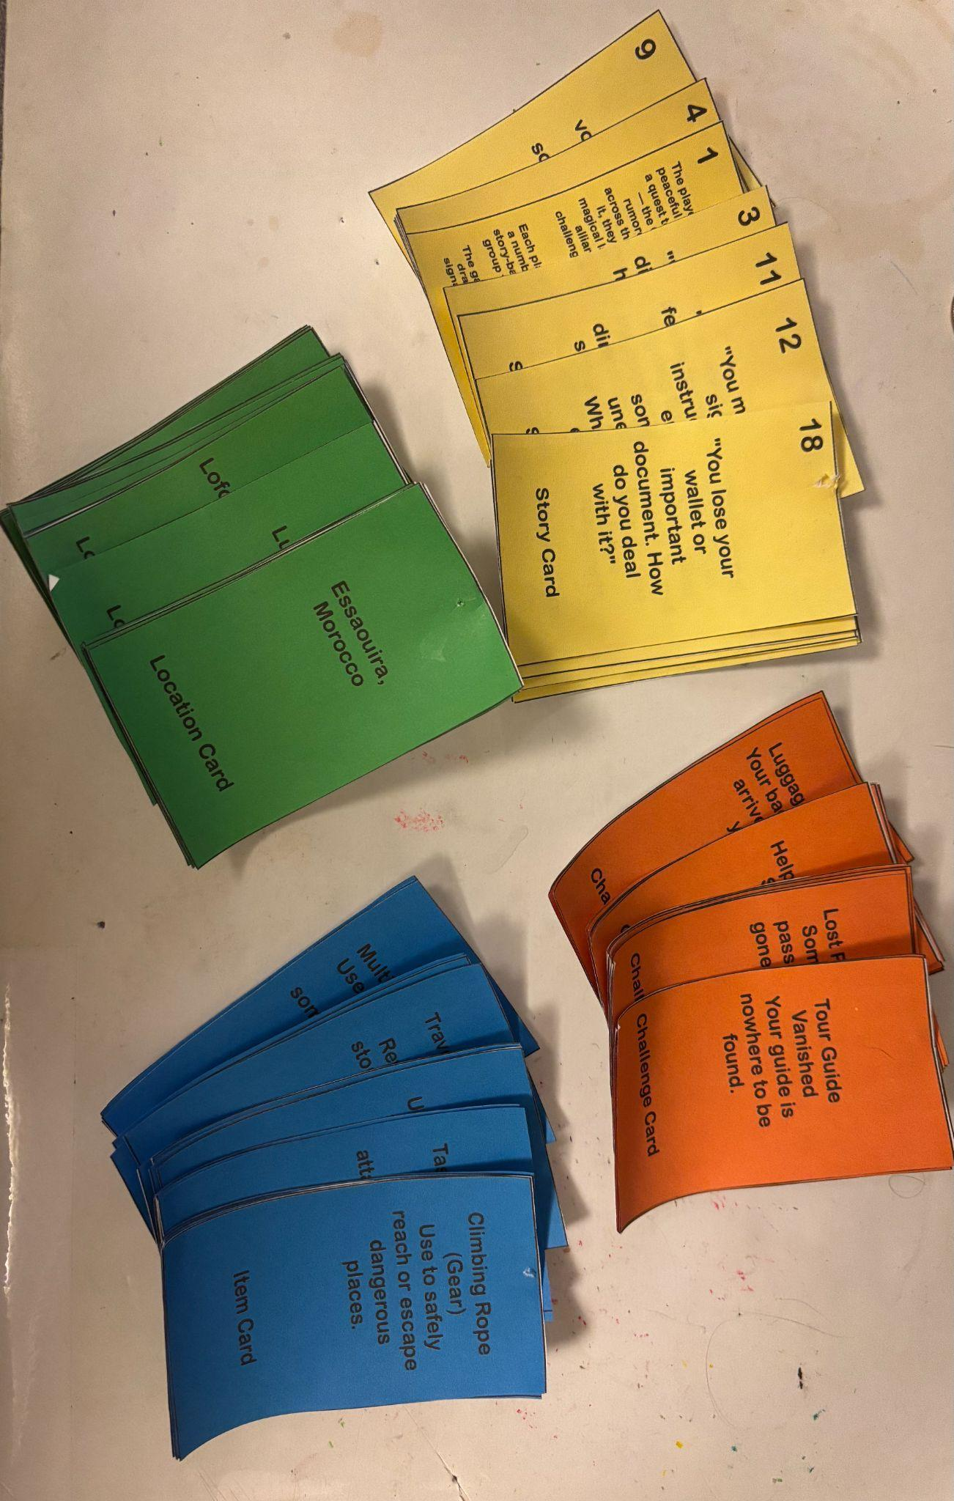
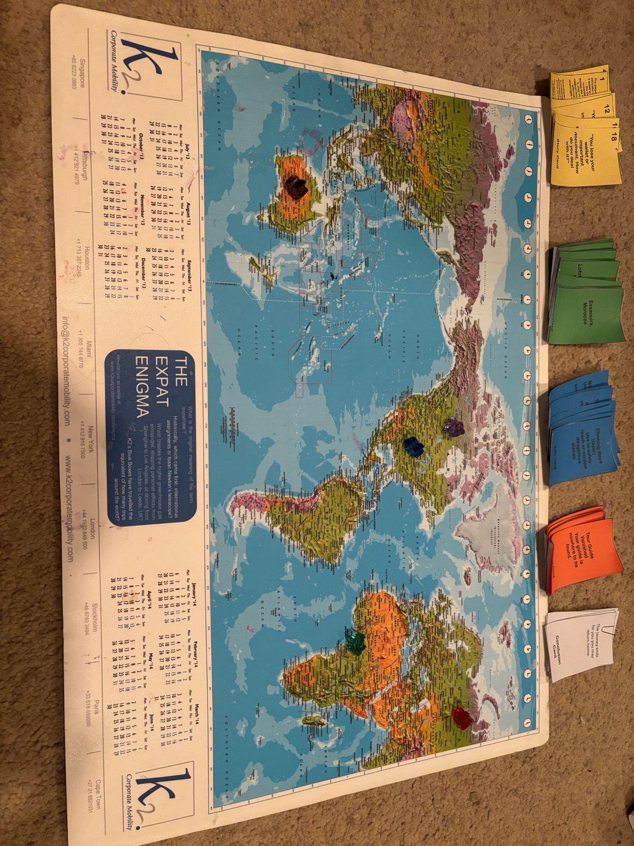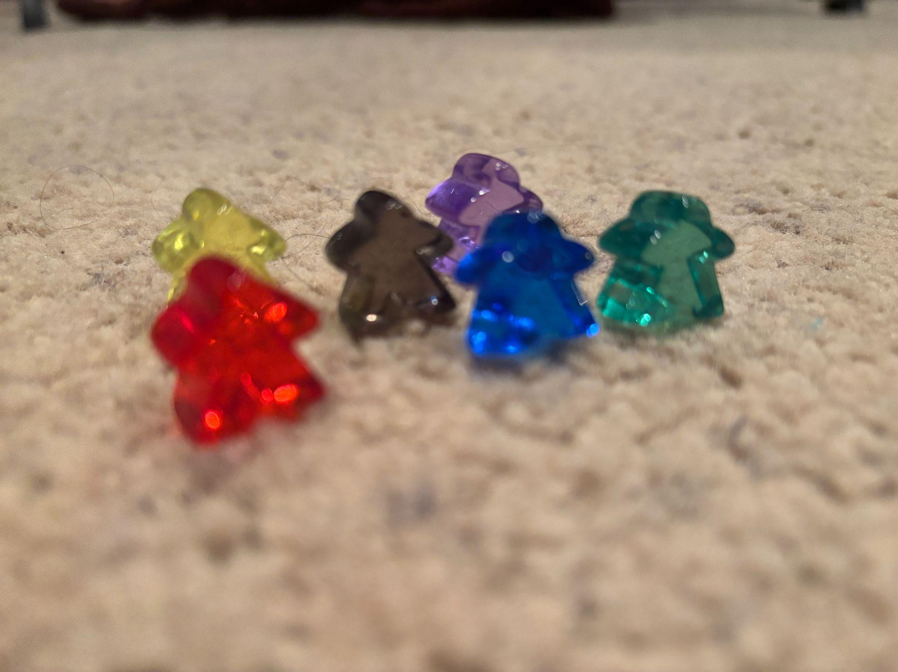
  - Details of the pieces: Each game piece was a different player that could choose between colors. The cards consisted of Location, Challenge, Item, Transportation and Story cards

Process photos – making
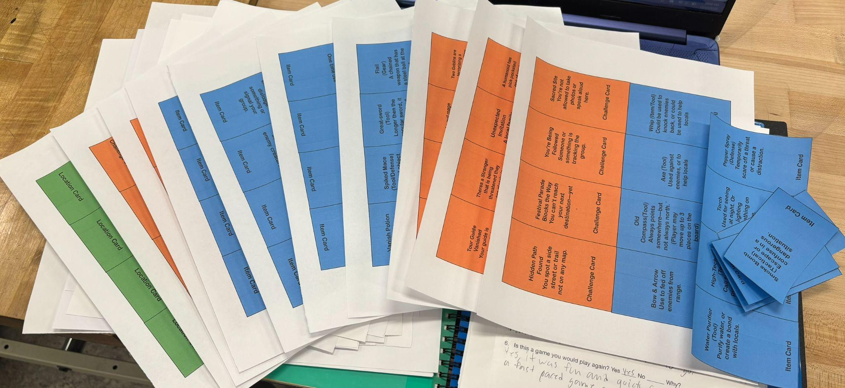

Design iterations – changes to the board, cards or pieces
- Since I didn't have any player pieces, I borrowed Meeples from a classmate. Which I used for my game.
- First Iteration of the game board: I changed the game board to have a yellow line that crosses over to the other continents.
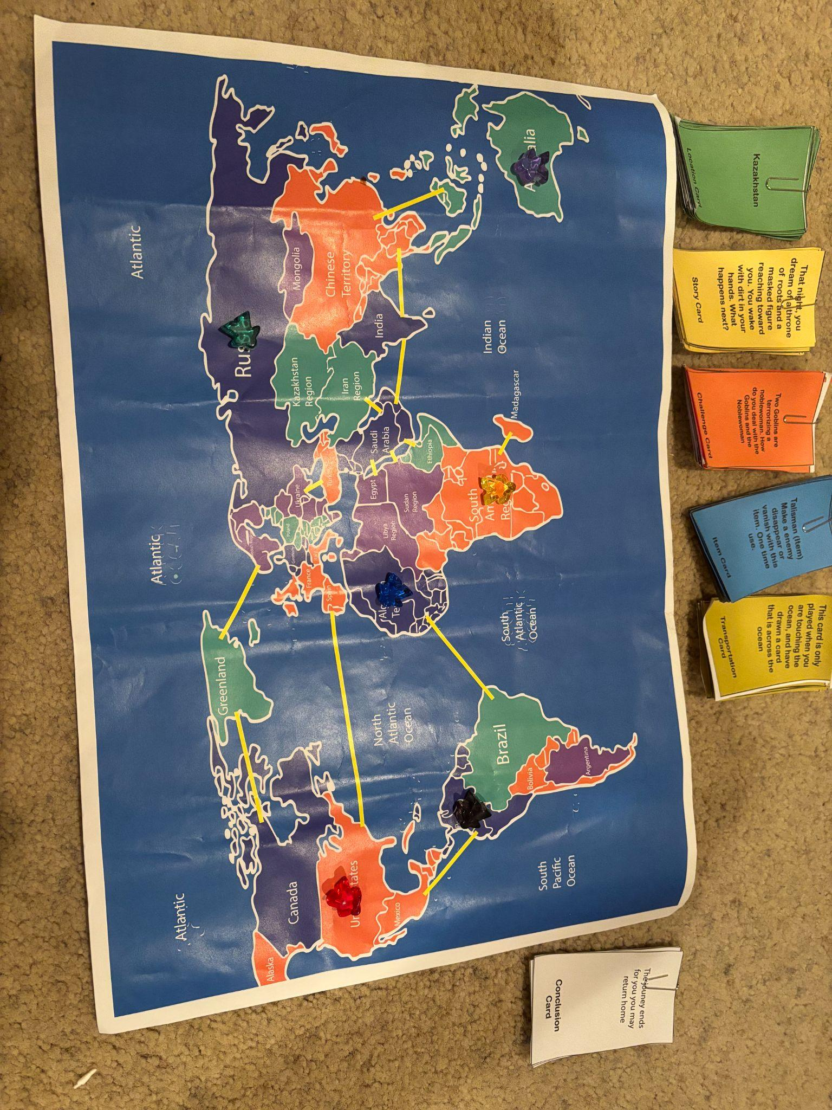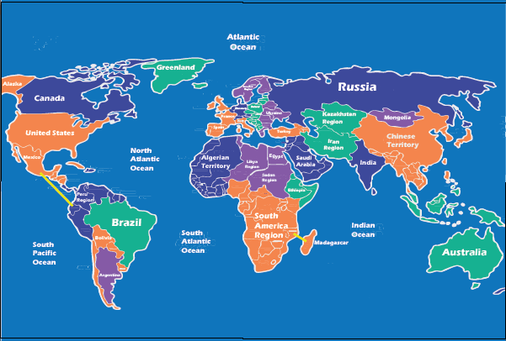
Second iteration made to the game board: I added the Yellow lines that indicate the use of the Transportation cards.
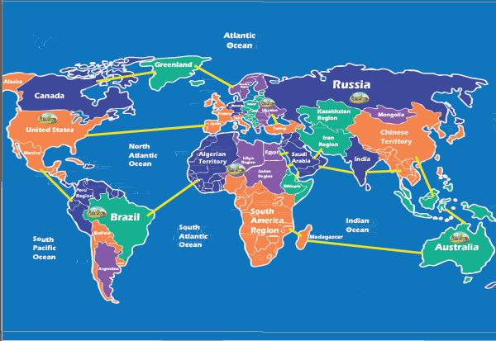
Second iteration of the game cards: I removed the numbers on the story cards, they confused players too much. I also changed the Challenge, item, and the Location cards to fit their preferred uses for my next play test.
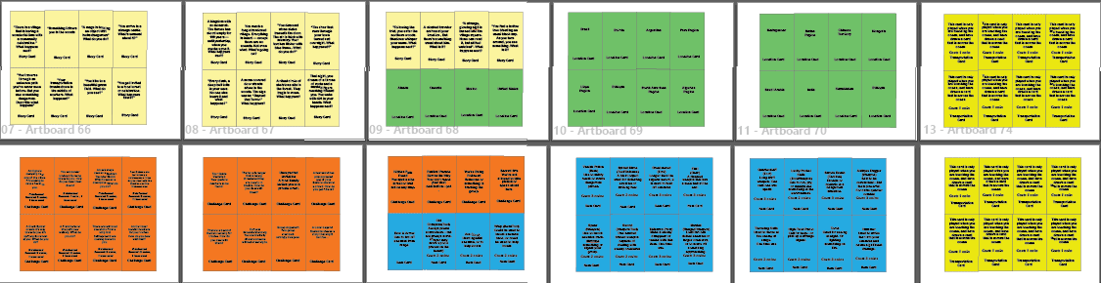
Third iteration of the game: I added the new rules to the cards, for the conflict cards I added the enemies with the rewards. I replaced the location cards with “starting location cards. I removed the transportation cards and conclusion cards. Overall I added and removed rules and made new changes. I fixed the rules to match up with the cards as well.
An overview of changes made
These are the new rules I made for the second change to my game.
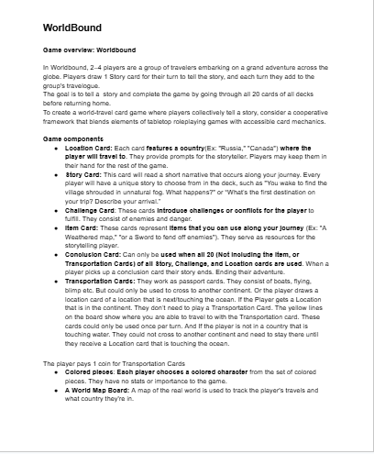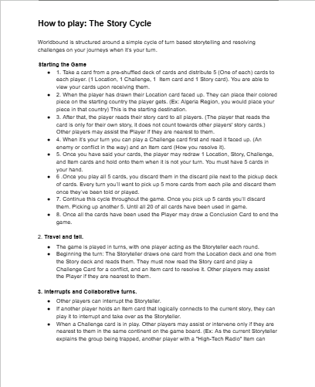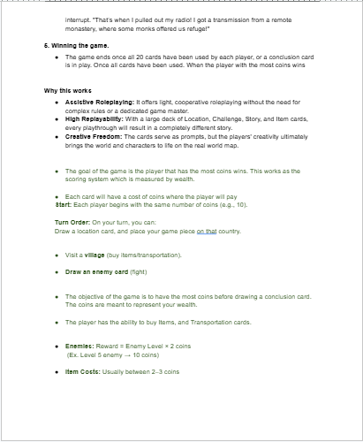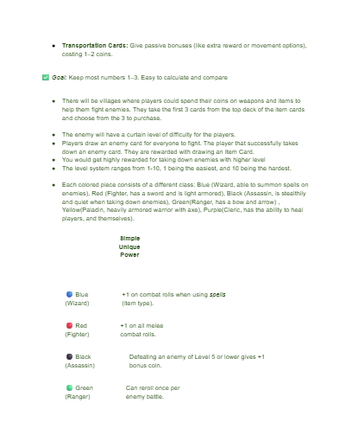
Second Rules Made:
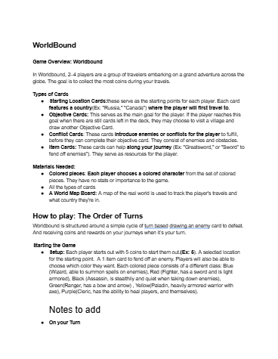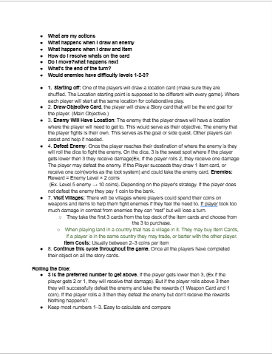
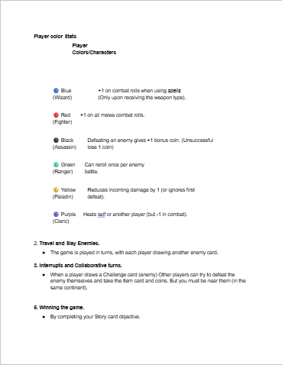
I refined the rules so that when the player goes around the board they can trade, buy, and sell item cards on their journeys. I changed the challenge cards to enemy cards to where each player would go around and pick a card from the deck. The cards would have an enemy that the players would fight, I got this idea from when I played the game Munckins during our earlier classes in the semester.
Final Rules made:
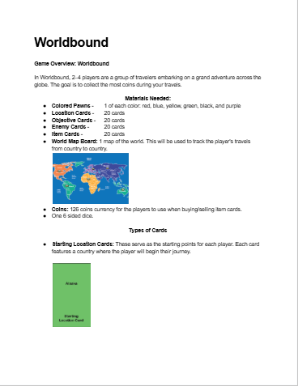
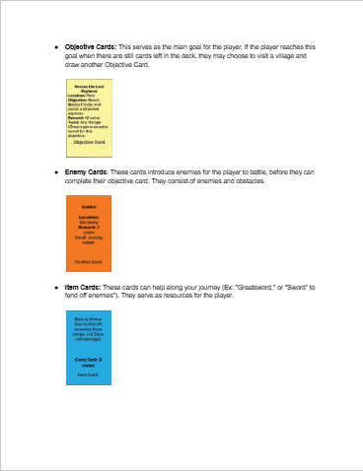
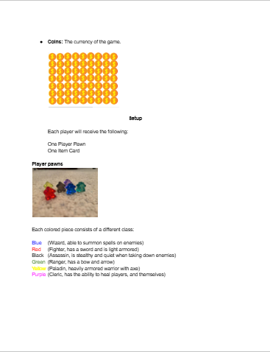
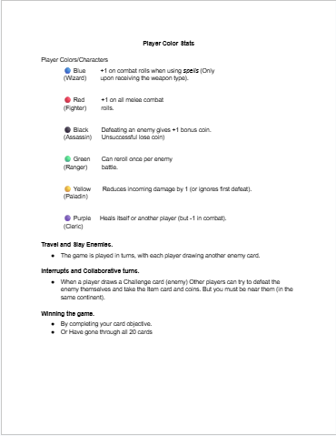
These are the final polished rules for my game.I reworked the cards, added new rules and made adjustments to gameplay.
Play test notes:
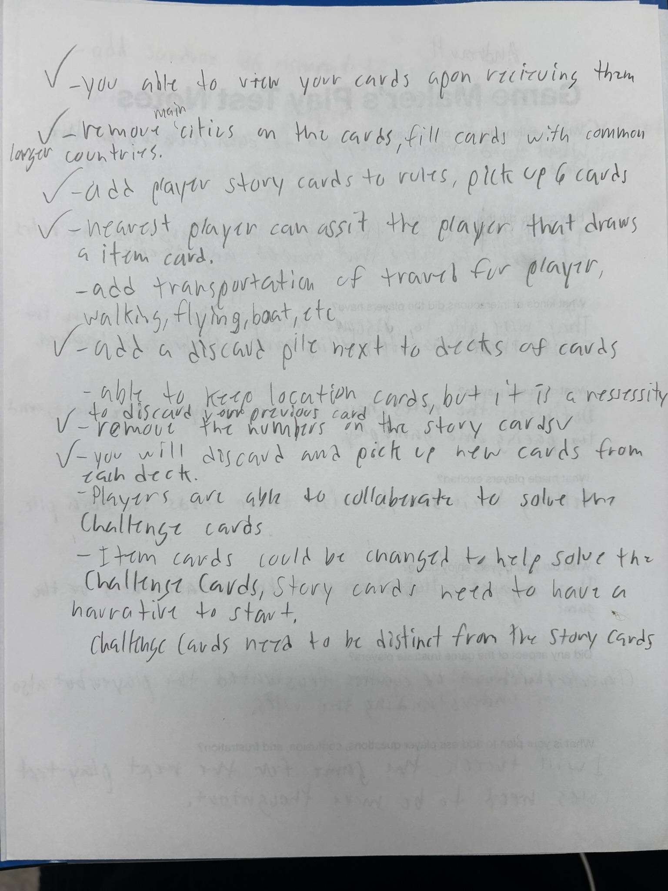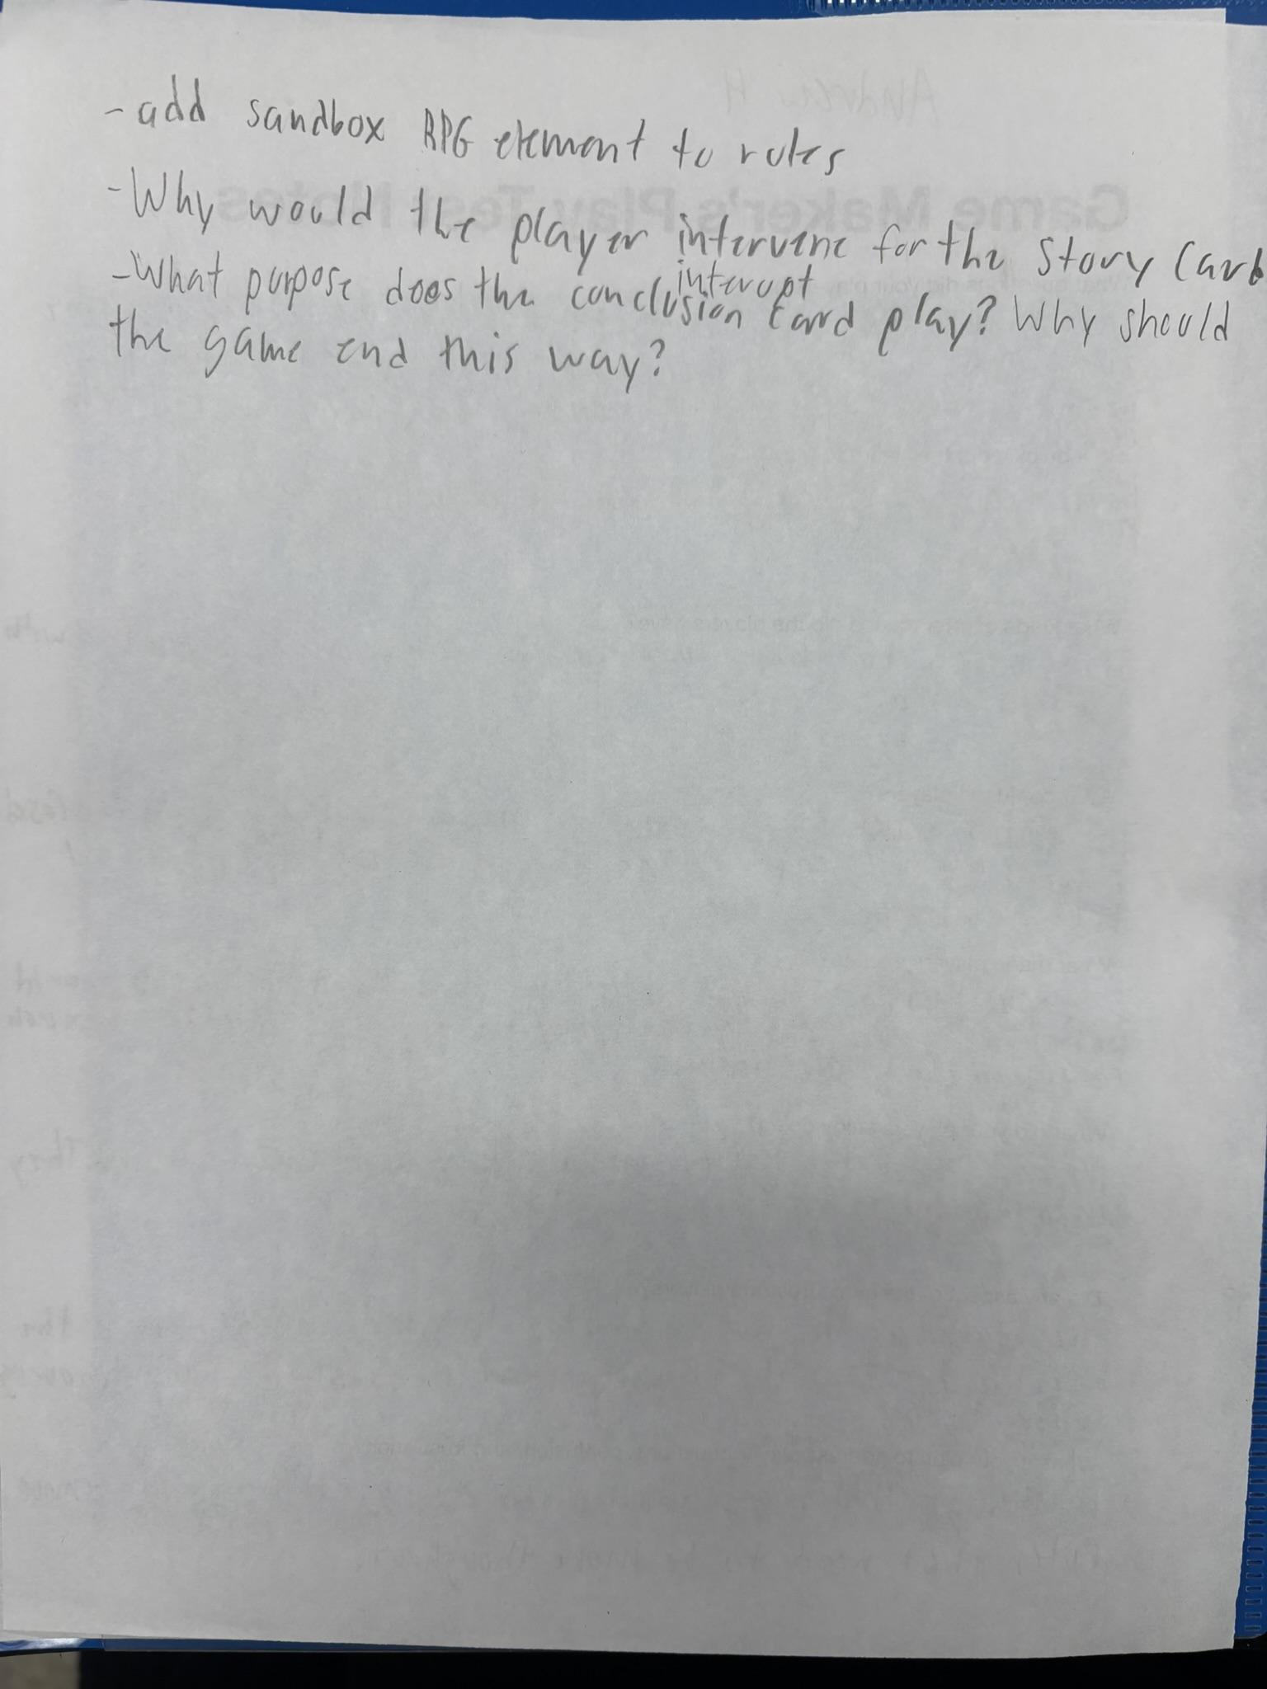
First iteration made of Worldboard: This a regular world map, and the cards i made in illustrator
Third iteration made of Worldboard:
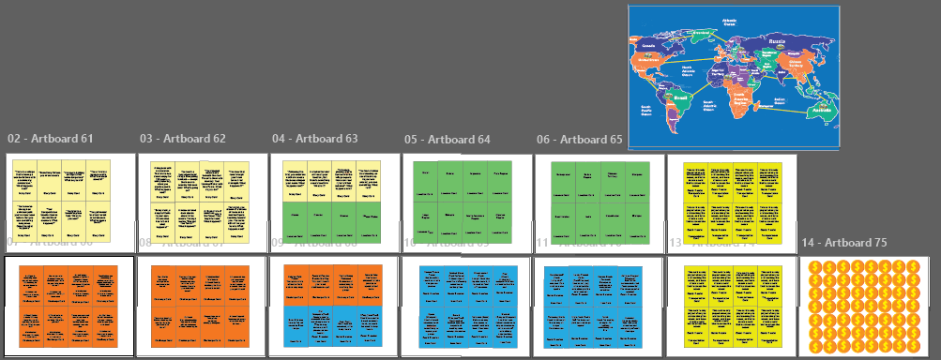
Final iteration made of Worldboard:
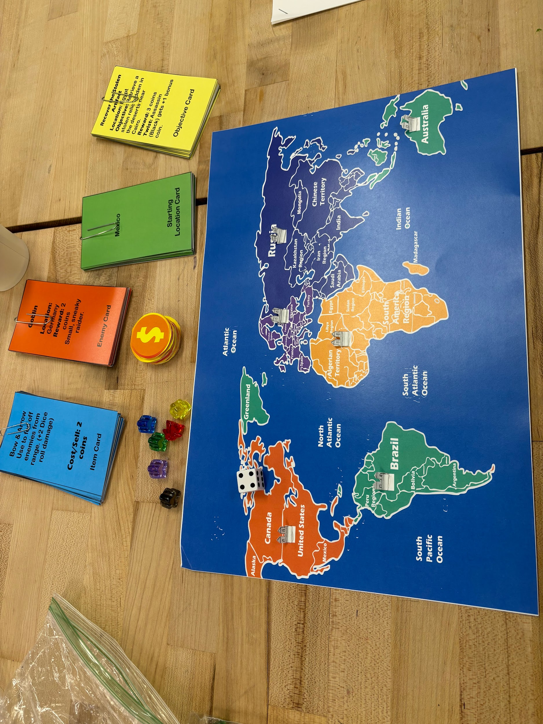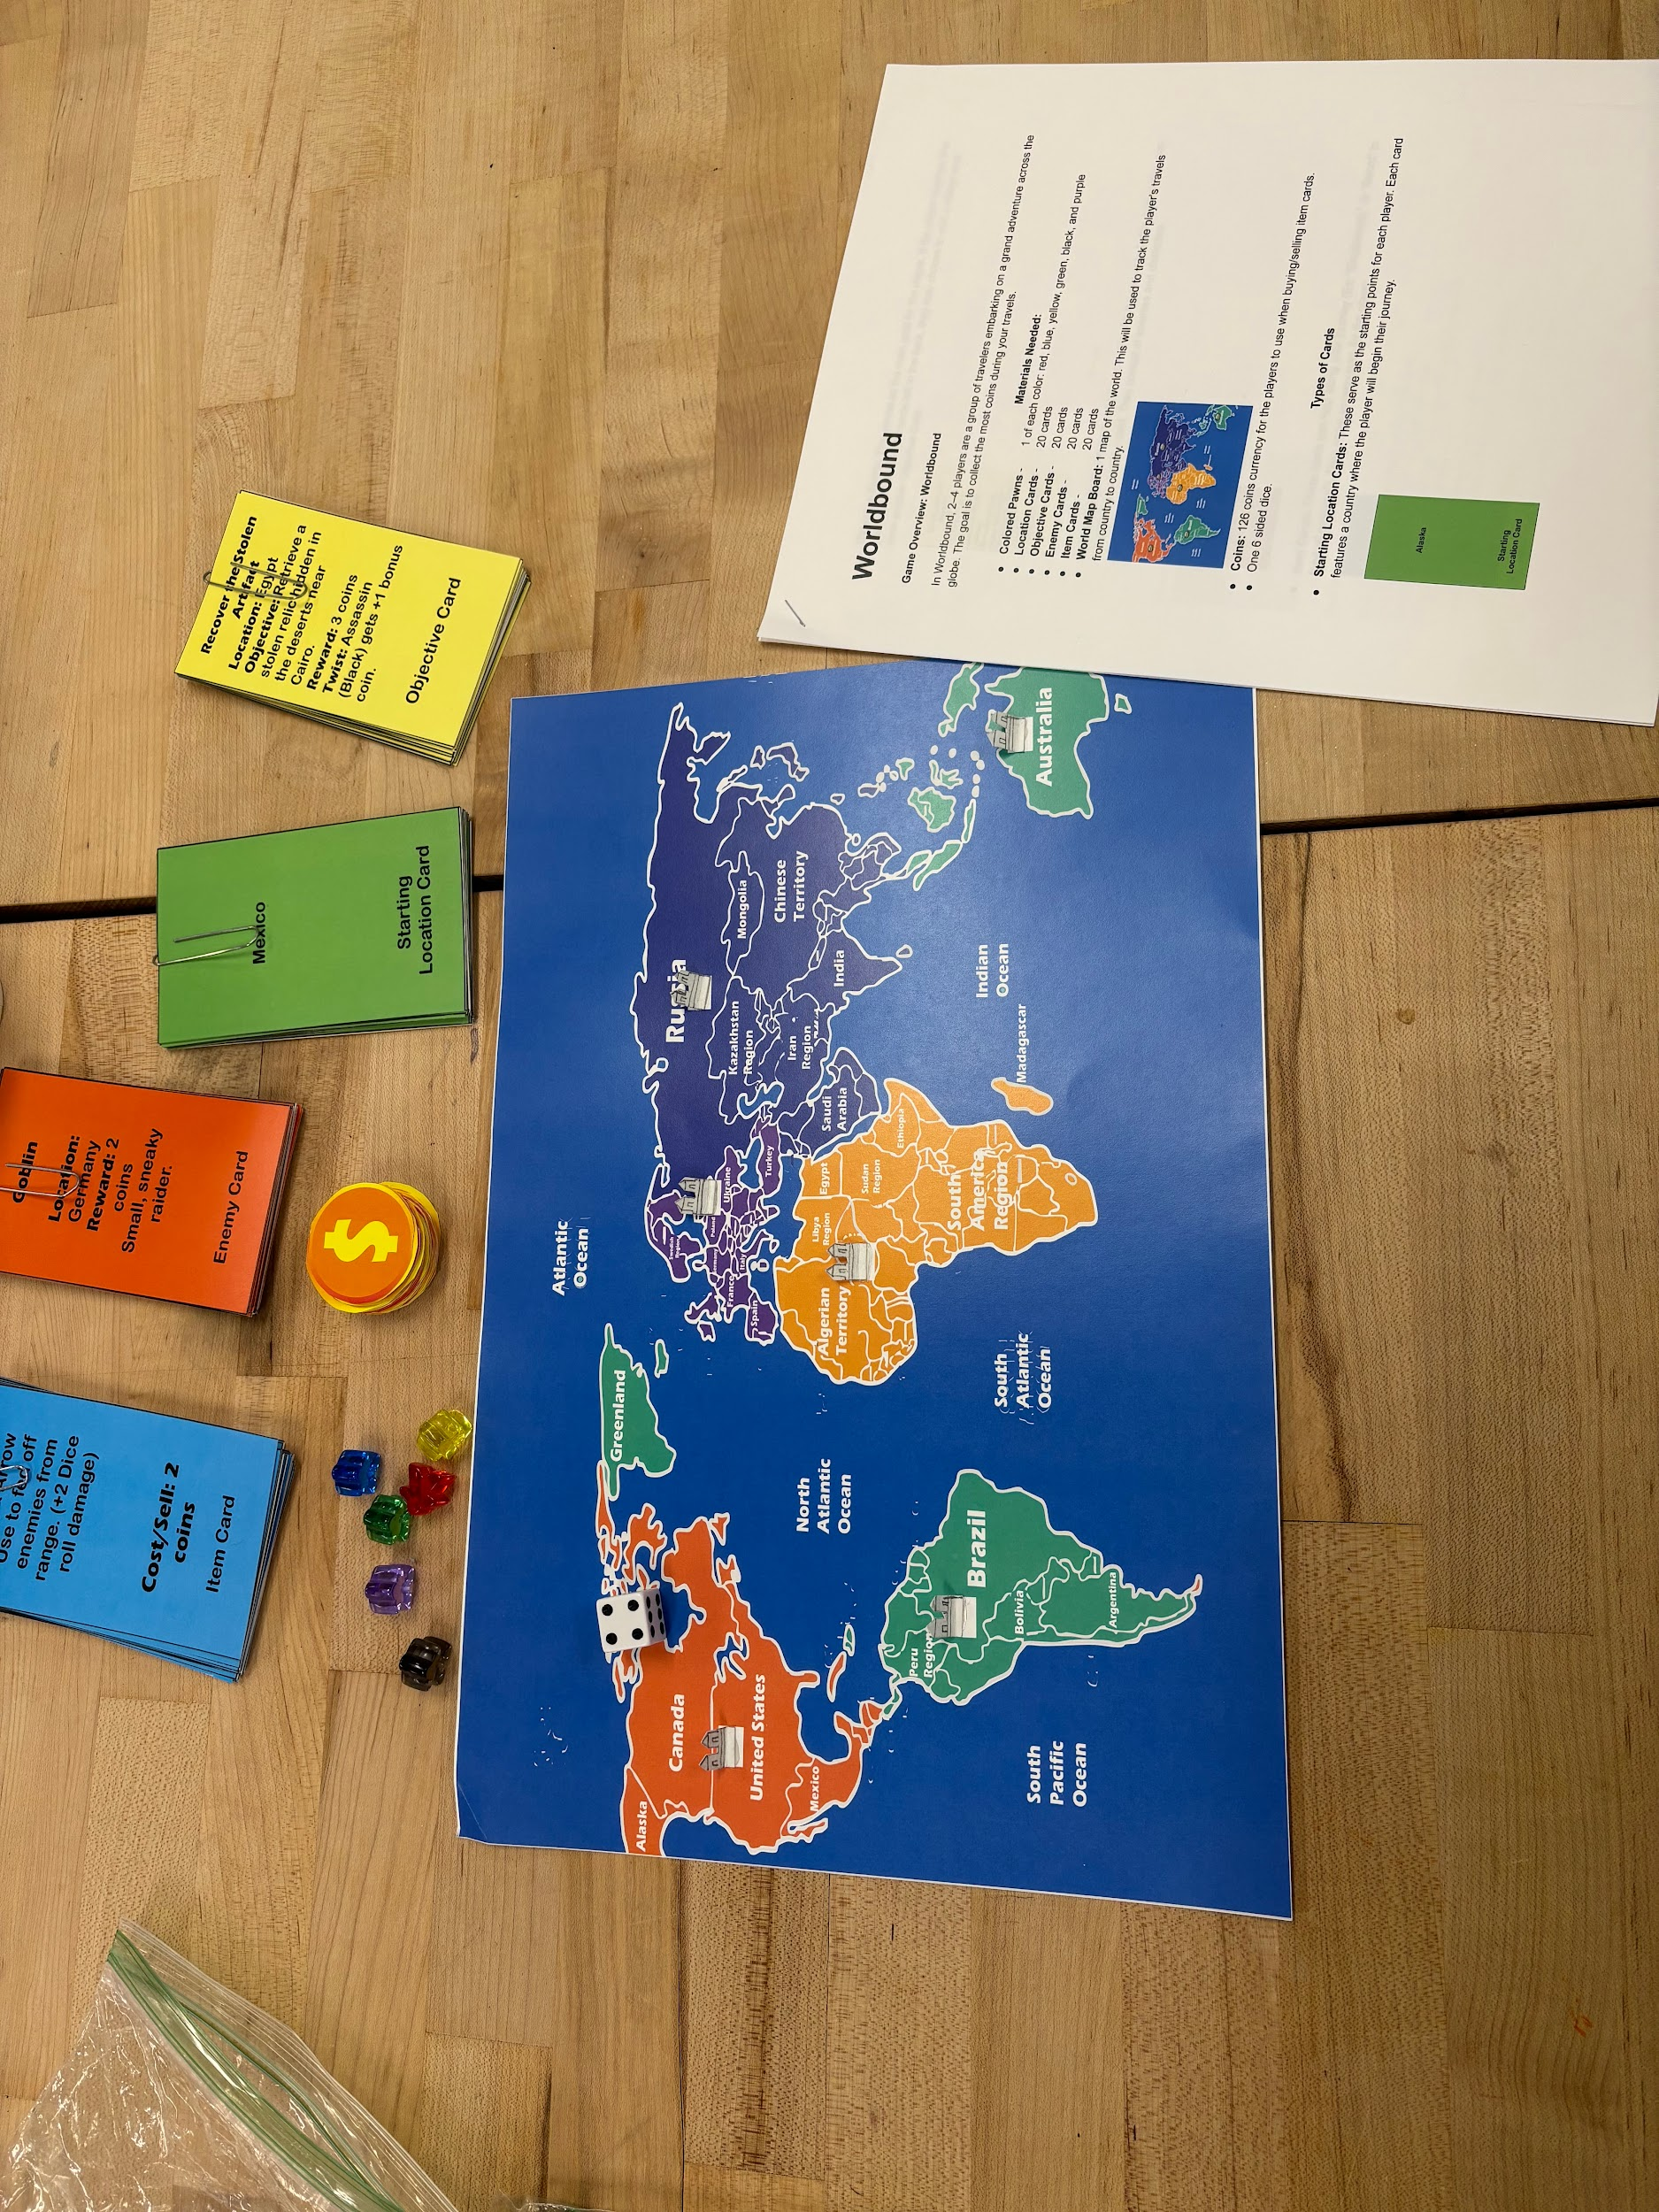
This is the final version of the game made.
Your thoughts and lessons learned from play testing
During the development of my game Worldboard. I mostly learned just how challenging game making could be in terms of rules, mechanics, and collaboration between players as they play. I learned how much thought and engineering goes into making games, and I originally thought that it was gonna be much easier than the typical video games we like to play. But I found that board games are almost just as hard to think about and play test as the video games.

