Second game: Patchwork city
- Rules of Patchwork City: These are my first rules I made for our collaborative game.
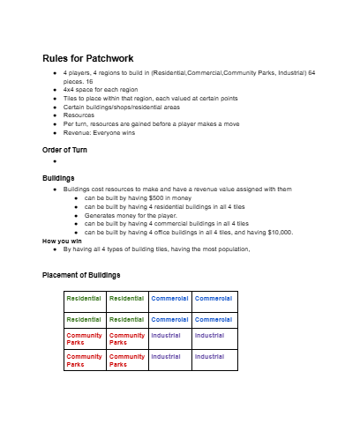
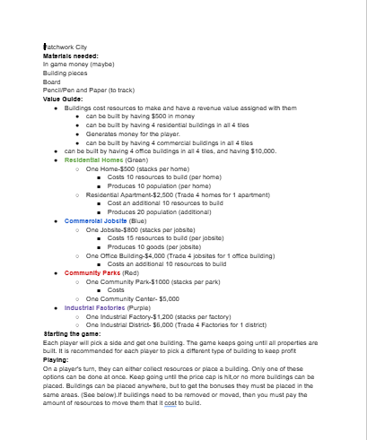

The game when setup
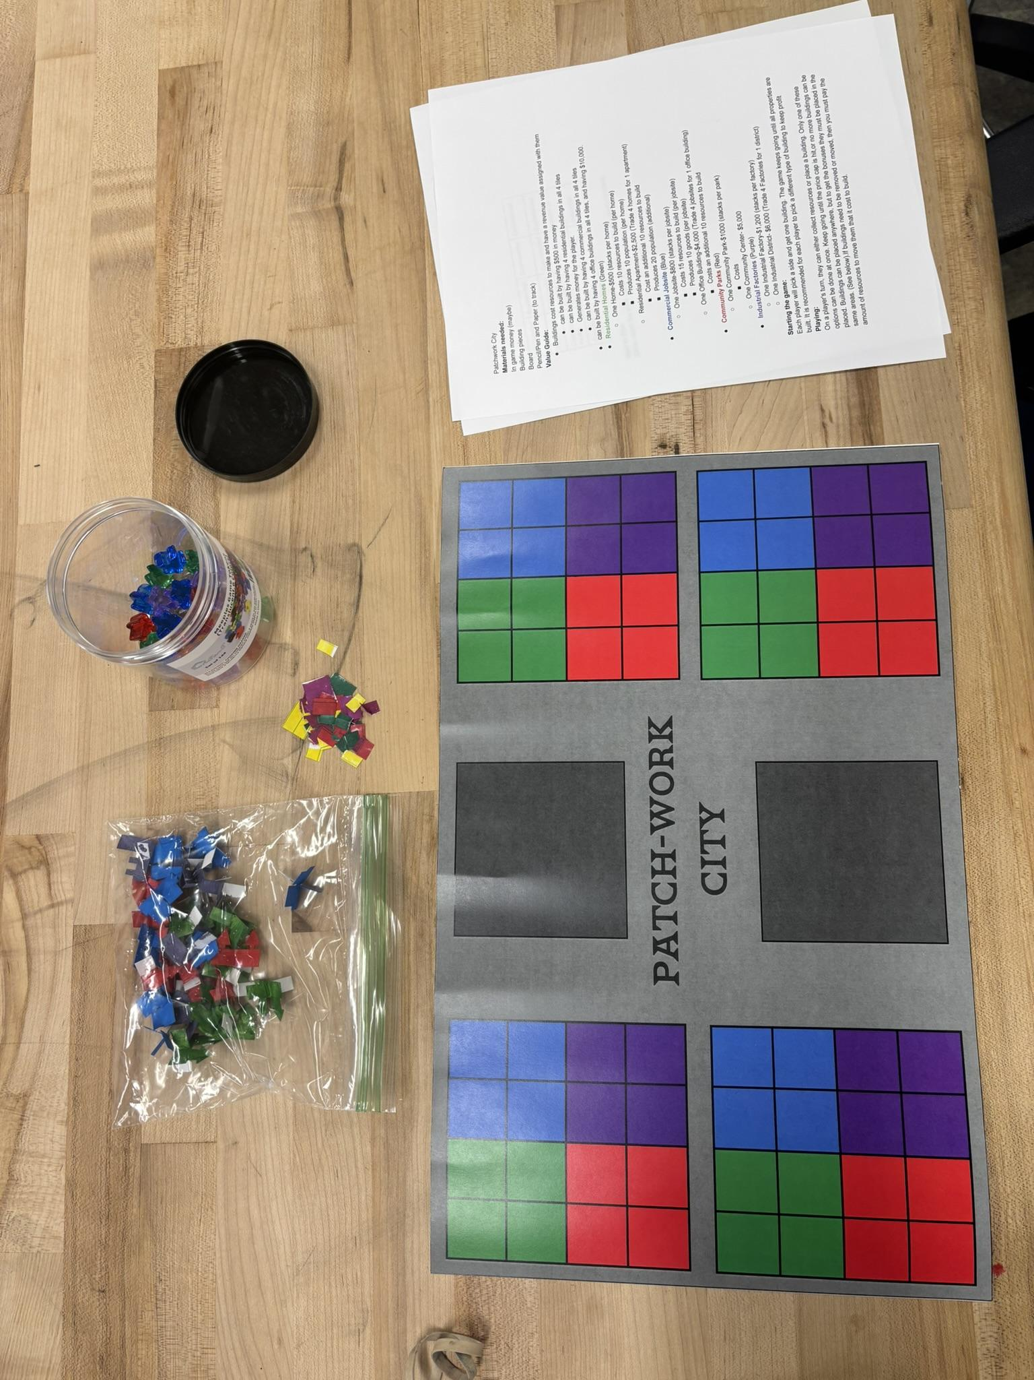

Process photos – making

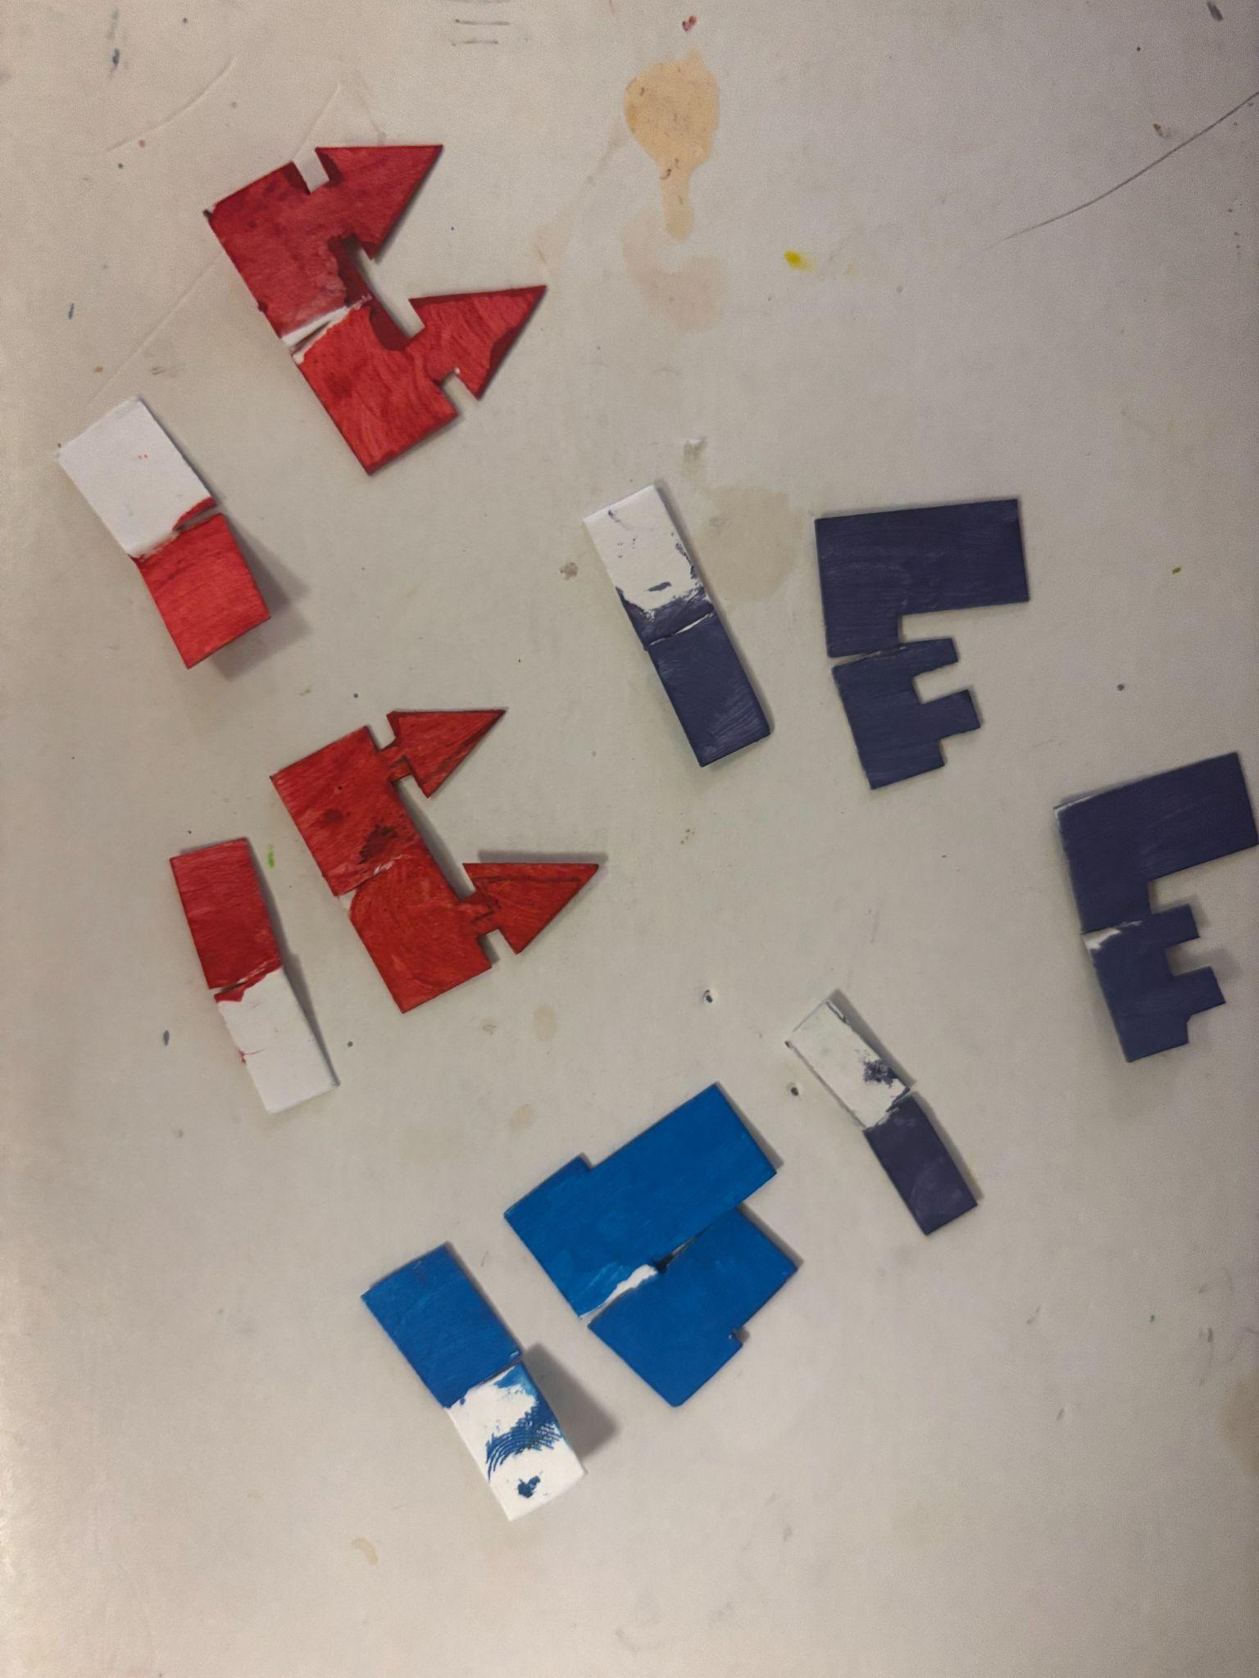

Design iterations – changes to the board, cards or pieces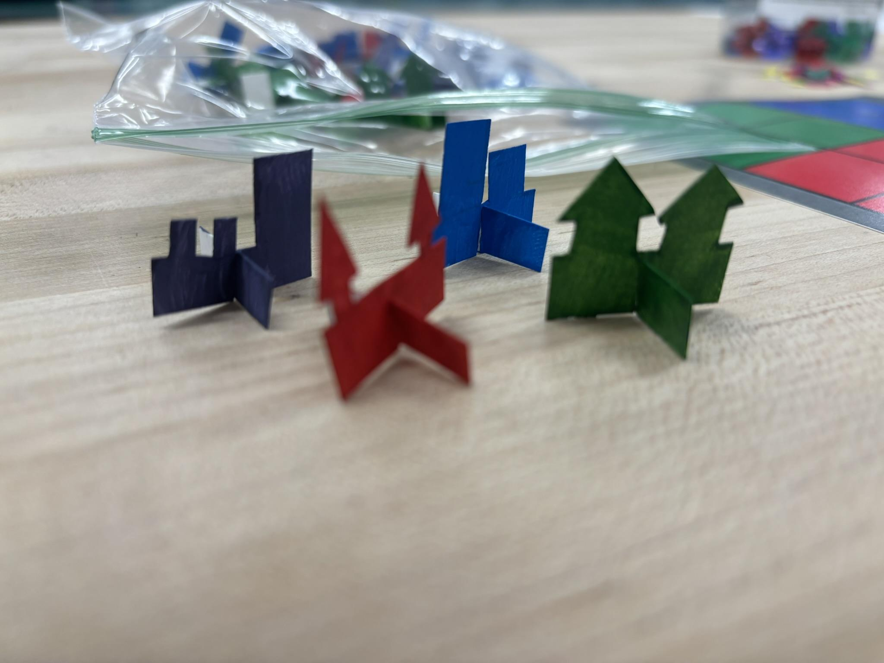
Details of the pieces: The piece were for each of the different city components( Residential,Commercial, Community Park, and Office)

An overview of changes to make
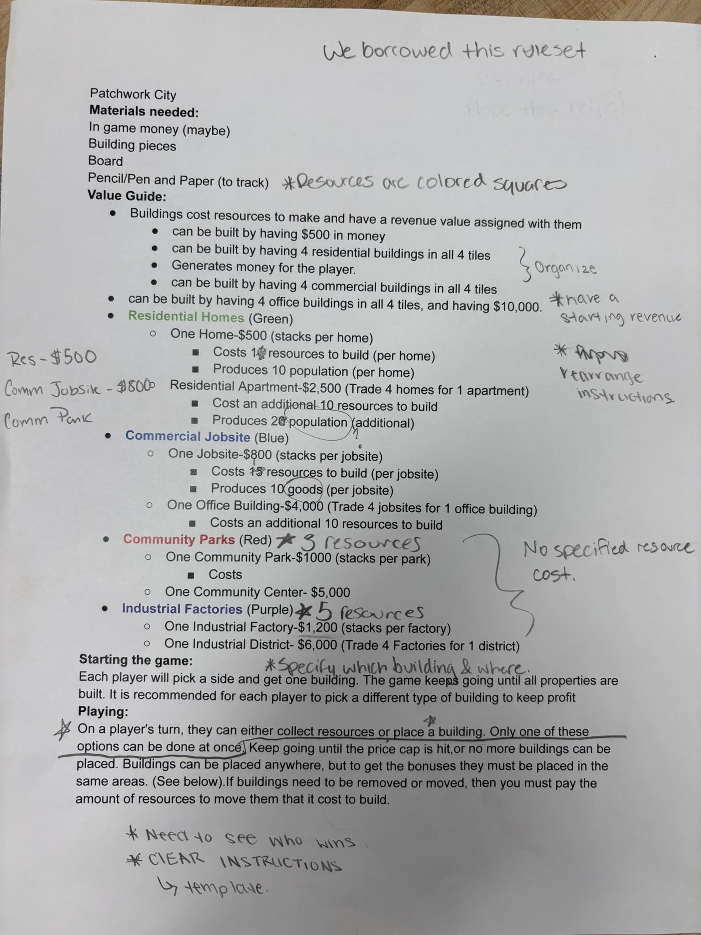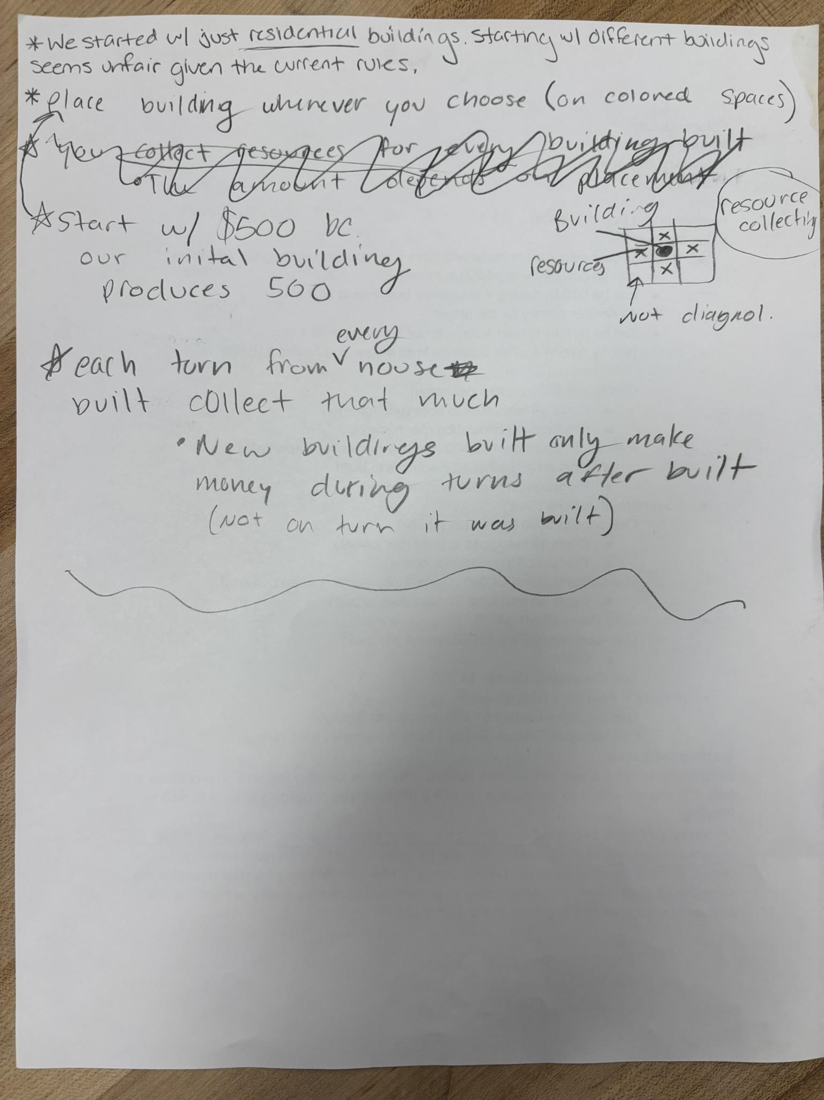
The rules need much more refining and cleaning up. Our first iteration we didn’t have money to use so we had to borrow money from class. Overall the game was unfinished.

An overview of changes made
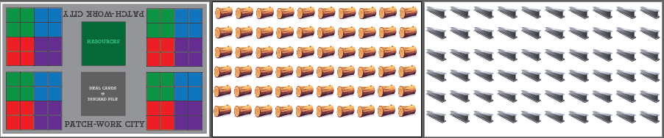
In this image i added another game element, wood and steel for the resources that players will gather to build their cities.
The rules were rewritten by the play testers since the game was very unfinished and not well thought out as we initially hoped. They helped us a lot with coming up with ways to improve the game to have better gameplay experiences.
Your thoughts and lessons learned from play testing
When we made the rules we weren’t too sure how the game would play out. Thankfully we got many suggestions for where to take the game in another play test. The rules and the mechanic needed much more thought put into them. They confused players and played the game how they perceived it. So they helped us change the rules and encouraged us to put more thought into them.

Ideas for other Collaborative games

1. Signal Lost
Genre: Puzzle / Communication
Core Idea: Two (or more) players are stranded on different ends of the game board (damaged space station). Each player’s card shows different parts of the ship and has information needed to fix the ship. They must communicate effectively and share clues to repair the ship's systems before the oxygen meter runs out.
Mechanic Hook: As players progress, there will be obstacles, like asteroids, space rocks that could collide into the ship. Causing their mission to repair the ship more difficult.

2. The Patchwork City (The choice we ended up choosing)
Genre: City-building / Resource management
Core Idea: Players have 4 different “districts” in their own cities. Each player has the ability to build their own cities from the ground up,
Mechanic Hook: Building placement affects their budget (Ex: your factory gives energy to your cities parks and gives off pollution).
Twist: Each player can see hidden adjectives that the other players can’t see, requiring trust and teamwork. When asking for materials or gaining trust with each other.
Documentation of your first game will be worth 10 points, your second game will be worth 20 points, and your third game will be worth 40 points. A fourth game will be worth 80 points.

