**Regular Solitaire Game Rules:**

**Set up-**

1. Starting from left to right, deal cards from a shuffled card deck into the seven piles that form the tableau, which is the main playing area. You place the first card face up to make the first pile, then you deal one card face down for the next six piles. Then starting from left to right, place one card face up on the second pile, and deal one card face down on the four piles to your right. Keep doing this until you have dealt all seven piles.
2. Put the undealt cards into the Stock. You will draw from this pile of cards throughout the game.
3. Leave space for the four foundation piles, which is where you will build the foundations for each suit as you progress through the game. You place the ace for each suit in each pile, followed by the 2, and so on until you get to the king in game play.

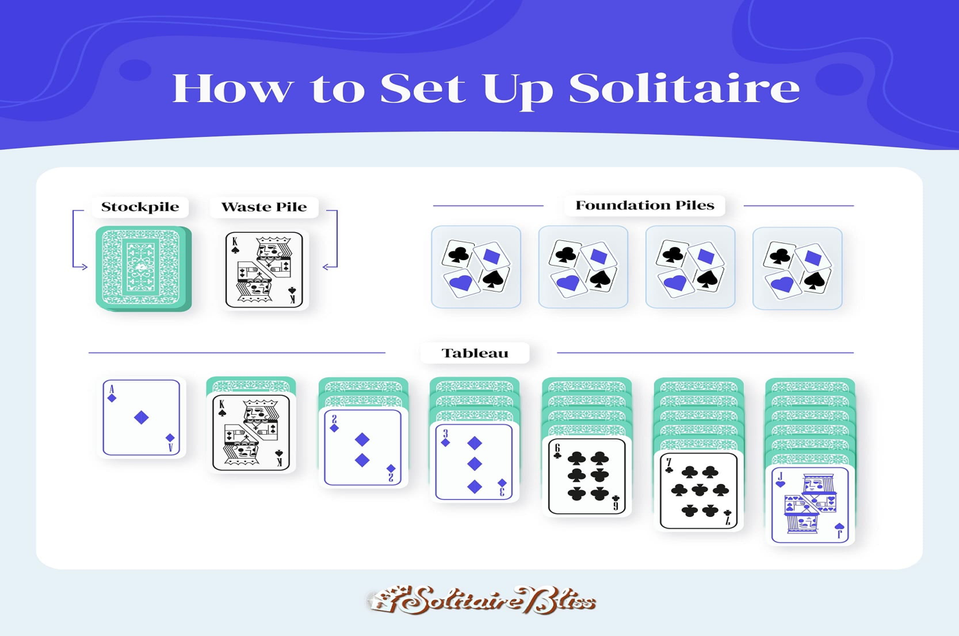

**How to play-**

1. **Survey the tableau and decide your first move**

You can only move face-up cards. Aces can be put in the foundation piles. Cards can be moved between columns as long as they are alternating color and descending order. You may have several moves, and you want to rearrange as many face-up cards as you can to reveal face-down cards in the columns.

**2. Start foundation piles in ascending order (ace to king)**

You must begin your foundation piles with an ace, and each pile must be a single suit in ascending order (ace to king). If you have an exposed ace on the tableau when you start the game, you can immediately move it to a foundation pile.

For example, if an ace of hearts is face up, you can move it to a foundation pile, and if you see a 2 of hearts face up, you can move that 2 on top of the ace on the foundation pile—and then the 3, and the 4, and so on. Remember, they must all be of the same suit. If you have a 2 of diamonds, you can’t put it on top of an ace of spades—you have to wait until you get an ace of diamonds to build the foundation pile for the suit of diamonds.

**3. Rearrange your piles using face-up cards**

You can build up stacks of cards on the tableau so that you can keep revealing new cards. However, all cards exposed face up must be stacked in descending order and with alternating colors.

For example, if you had a queen of hearts exposed on your tableau, you could stack a jack of spades on top of it, and a 10 of diamonds on top of the jack, and so on. Suit doesn’t matter, only color and descending order does in the tableau. With that queen of hearts, you need the next lower card (a jack) and the opposite color (black).

You can move cards individually or entire columns at one time. If you see a face-up king, take the whole column you just built (queen of hearts, jack of spades, and 10 of diamonds) and place it onto the king. Now your column still descends and alternates by color.

If you move a face-up card or group of cards to another column, check to see if you have exposed a face-down card. Anytime your move exposes a face-down card on the tableau, you can turn that single card over, making it face-up on that tableau pile. Now you have a new face-up card to play.

**4. Draw from stockpiles/waste piles to make moves**

If you don’t have any moves on the tableau—meaning you can’t move anything to the foundation piles or you have no moves to make—you can draw from the stockpile.

You can draw one card at a time from the stockpile. Draw the card and lay it face up on your waste pile. You can try to play this card, just like any other face-up card, by placing it anywhere on the tableau or foundation piles. If you can’t play the card, leave it face up on the waste pile.

When you have a waste pile, check it before you draw from the stockpile. You always play the face-up card on the top of the waste pile and play through the waste pile by continuing to play any face-up card revealed on top. You cannot shuffle though the waste pile to find a card you can play, only the top card can be played.

If you have no additional cards to draw from the stockpile, simply turn over the waste pile and make it the stockpile. Never shuffle the waste pile.

**5. Restart empty tableau columns with a King**

If you have removed all of the cards from a tableau column, leaving an empty space, you can start a new column with a king. You can place a single king or move an entire column of cards that begins with a king into the empty space. Ideally, you should have seven columns at all times in your tableau, but if you do not have a king to fill the empty space, wait until one is revealed to place it in the empty space.

**How to win-**

All cards are in ascending order on your foundation piles and no cards are left either face up or down in your tableau. Sometimes you can get stuck with no moves to make, and the game is over.

**Rules to remember-**

In the tableau, the cards go in descending order (high to low) with alternating colors.

In the foundation piles cards ascend (low to high) with the same suits starting with an ace.

**Recreated Solitaire Game Rules**

Set up is the same as real solitaire (refer to the set up paragraph above)

**How to play-**

1. **Survey the tableau and decide your first move**

You can only move face-up cards. Kings can be put in the foundation piles. Cards can be moved between columns as long as they are ascending order (low to high). You may have several moves, and you want to rearrange as many face-up cards as you can to reveal face-down cards in the columns.

**2. Start foundation piles in descending order (king to ace)**

You must begin your foundation piles with a king, and each pile must be a single suit in descending order (king to ace). If you have an exposed king on the tableau when you start the game, you can immediately move it to a foundation pile. Just like original solitaire, you will have four foundation piles, stacking the same suits together.

**3. Rearrange your piles using face-up cards**

You can build up stacks of cards on the tableau so that you can keep revealing new cards. However, all cards exposed face up must be stacked in ascending order. Diamonds and Hearts can go together on the same column and Spades and Clubs and go on the same column. No other suits can go together on the same column in the tableau.

You can move cards individually or entire columns at one time.

If you move a face-up card or group of cards to another column, check to see if you have exposed a face-down card. Anytime your move exposes a face-down card on the tableau, you can turn that single card over, making it face-up on that tableau pile. Now you have a new face-up card to play.

**4. Draw from stockpiles/waste piles to make moves**

If you don’t have any moves on the tableau—meaning you can’t move anything to the foundation piles or you have no moves to make—you can draw from the stockpile.

You can draw one card at a time from the stockpile. Draw the card and lay it face up on your waste pile. You can try to play this card, just like any other face-up card, by placing it anywhere on the tableau or foundation piles. If you can’t play the card, leave it face up on the waste pile.

When you have a waste pile, check it before you draw from the stockpile. You always play the face-up card on the top of the waste pile and play through the waste pile by continuing to play any face-up card revealed on top. You cannot shuffle though the waste pile to find a card you can play, only the top card can be played.

If you have no additional cards to draw from the stockpile, simply turn over the waste pile and make it the stockpile. Never shuffle the waste pile.

**5. Restart empty tableau columns with an Ace**

If you have removed all of the cards from a tableau column, leaving an empty space, you can start a new column with an ace. You can place a single ace or move an entire column of cards that begins with an ace into the empty space. Ideally, you should have seven columns at all times in your tableau, but if you do not have an ace to fill the empty space, wait until one is revealed to place it in the empty space.

**How to win-**

All cards are in descending order on your foundation piles and no cards are left either face up or down in your tableau. Sometimes you can get stuck with no moves to make, and the game is over.

**Rules to Remember**

You must begin your foundation piles with a king and each pile must be a single suit in descending order (king to ace)

Cards exposed face up must be stacked in ascending order.

Diamonds and Hearts can go together on the same column and Spades and Clubs and go on the same column. No other suits can go together on the same column in the tableau.

If you have removed all of the cards from a tableau column, leaving an empty space, you can start a new column with an ace.