# Text Description automatically generated with medium confidenceSOUL: V. 7.1

# Chapter 1: Character Creation

Character creation in Soul is divided into a few different steps to make the whole process as easy as it can be. These steps are

* Race Selection
* Affinity Selection
* Attribute Allocation  
  - Combat Attribute Allocation
* - Exploration Attribute Allocation
* Skill and Talent Allocation  
  - Combat Skills and Talents
* - Exploration Skills and Talents
* Weapon Mastery
* Persuasion, Composure, Hunger, Fatigue
* Starting Equipment
* Artifact Rolls
* Finishing Steps

# Part 1: Race Selection

When you first begin character creation, you’ll probably have a name and an idea of what kind of person your character is. Maybe, you’ll even have a bit of a background picked out for them. Part of figuring out how your character actually fits into the world is choosing their race. There are many different races of men in Soul, each with their own strengths. Below, you’ll find a table that includes all the playable races and their accompanying stat bonuses, as well as a brief description of the race in question. For more detailed profiles of each race, you can consult the companion book.

Under each column, you’ll find different information about the race in question. The Race column contains the name of that particular playable race.

HP is the base health point value for the corresponding race. This is multiplied by one of your stats later to determine total HP.

The Affinity column lists restrictions on Affinities, which are your character’s elements. If this says, “Fire,” it means that race has to start with Fire as their major affinity. If it says, “Any,” they can choose any. If there are multiple elements listed, they may choose from a that list. Lastly, if a race is listed as, “None,” it means they do not have any elemental affinities available to them.”

The ”Bonuses” Tab lists any Attribute and Skill bonuses that are associated with a particular race. They will say ‘+’ or ‘-‘ followed by a value and the associated Attribute or Skill. Attributes will be marked with an (a) and skills an (s) to help distinguish them.

The “Lore” column gives a brief description of the race’s physiology and history.

|  |  |  |  |  |
| --- | --- | --- | --- | --- |
| Race | HP | Affinity | Bonuses | Lore |
| Aeterni | 200 | Any | +1 Attribute Pt; +2 Skill Pt  +5% Experience Bonus | Ascended Humans. Immortal, tall, 6’8” average, pale grayish skin, eyes match major element. |
| Kalmaran | 200 | Any | +10 Technology (s);  May start with 1 Cybernetic | Southern Aeterni. Reclusive Tech worshippers. They see pre-war technology as a machine god with a soul they work to resurrect. |
| Apostii | 225 | Dark, Storm, Earth, Fire | +1 Attack(a); +1 Defense(a) | Exiled Aeterni following the Sons of Cronus cult. Split genetically from Aeterni during the apocalypse war due to a desire for more aggressive physiology. |
| Primordi | 225 | Any | +1 Major (a); +1 Strength (a); +1 Mind (a); +1 Soul(a); -10% experience gain | One of the original 144,000 Aeterni. Stronger, Smarter, angelic features, but arrogant, and abrasive to change. |
| Vulneri | 175 | None | +10% Experience Gain. +1 Defense(a); +1 Skill Pt per level. | Weakened Human, lacking powers and mortal. Resourceful, hardy, highly adaptable. |
| Pyrian | 225 | Fire,  Storm, Dark | +2 Major (a); +1 Vitality(a); +10 Melee Weapons(s) | Half Demon. Lean, Red skin, orange eyes, males horned. Females generally considered very attractive. |
| Torric | 225 | Storm | +2 Major(a); +2 Storm Mastery; +1 Attack(a) | Storm Aeterni. Gray tinted brown or blue skin. Indigo Blue or Yellow eyes, hair shades of gray and white. Believed to have been created by the Sons of Cronus. |
| Nyx | 175 | Ice | +2 Major(a); +1 Mind(a); +10 Crafting(s); +10 Dexterity(s) | Thin, tall Ice Aeterni. Pale, glasslike white or blue eyes. Live in the north and leave for 10 years on a journey when they turn 20. |
| Penumbri | 200 | Dark | +2 Major(a); +10 Soul Powers(s); +10 Perception(s)  +1 Strength(a); +1 Agility(a); -1 Soul(a) | Dark Aeterni. Muscular, Gray Skin, Purple, Green, or Indigo Eyes and Silvery Hair. |
| Vyr | 175 | Water | +2 Major(a); +15 Soul Power(s); +1 Strength(a) | Water Aeterni. Shorter, more webbed hands and feet, small fins on forearms and legs. Sharp teeth and less pronounced features. Gray-Blue Skin. |
| Nephilim | 225 | Earth | +50 Base Armor; +1 Defense(a); +10 Block(s) | Earth Aeterni. Very tall, strong, hardened skin with a stone-like scaling in certain areas. Horns on both males and females, sharp teeth, red hair, clawed fingers. |
| Mumure | 175 | Wind | +2 Major(a); +15 Dodge(s); +1 Agility(a) | Wind Aeterni. Reclusive, Nimble, Long Limbs and Feathered forearms, wild hair, clawed hands and feet. |
| Seraphi | 200 | Light | +2 Major(a); +1 Mind(a); +1 Soul(a); -1 Strength(a) +10 Soul Powers(s) | Light Aeterni. Native to the Moon, light skin and golden eyes/hair. Fair-featured and thin. |
| Pyrian Pureblood | 225 | Fire | +3 Major(a); +1 Strength(a); +1 Attack(a); -1 Defense(a) | Pyrian Royal blood of Cruxis. Bred to strengthen their demon blood. Very strong, very aggressive, horns, orange eyes with red sclera. Large incisors on bottom jaw. |

Once you’ve selected a race, make sure to copy that race’s bonuses into the ‘bonus’ spot on the corresponding attribute or skill. An example of what this might look like is included on the next few pages.

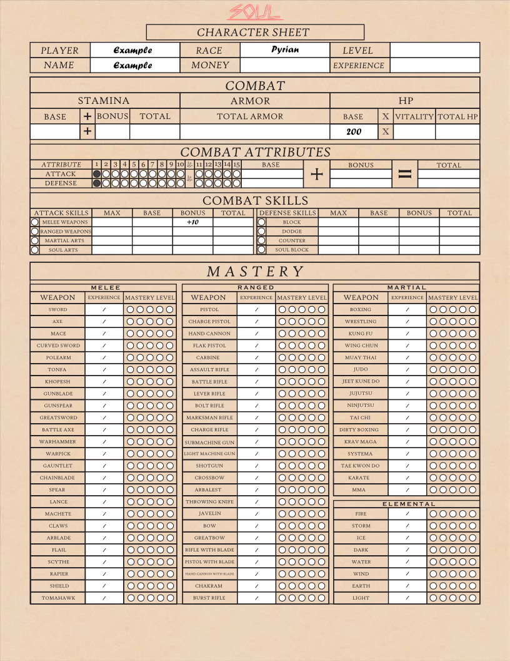

# 

# Part 2: Elemental Selection

After you’ve chosen your race, the next step is selecting your elements, or Affinities. Each and every character in soul gets at least one element, a minor element, which every player can choose. Depending on your race, you may get to choose a major element as well.

If you’ve picked a race that has an element associated with its Major, half of the hard part is done. Just go ahead and copy that element into the [Major] Box on the sheet. It will be listed under Exploration Attributes.

The difference between the Major and Minor elements is that Major elements start at a mastery level of 1. This can be recorded simply by putting a ‘1’ in the ‘mastery’ box of your major element. Don’t worry about what this means quite yet, it will be explained further when we get to that step. Major elements also start at 2 points by default.

The eight elements are Soul’s Magic system. The source of these powers is, of course, a character’s soul. Each element governs a different aspect of reality. In combat, and out of combat, the elements are a powerful tool to solve problems and get yourself out of a pickle. They are divided into aggressive and defensive elements, and each one does something a bit different from the others.

The aggressive elements are:

Fire: Stacks Damage and Builds strength over time

Storm: Lots of combo attacks and free casts

Ice: Status effects and Enemy Debuffing

Dark: Self Buffing, high damage single attacks

The defensive elements are:

Water: Self Buffing, Counter attacks and redirection

Wind: Powers build toward dodging and avoiding attacks

Earth: Build walls and shells of stone to protect yourself from damage taken

Light: Health regeneration, distract foes with illusions

Once you have your elements selected, both one Major and one Minor, just copy them into the corresponding box in the exploration attributes section of the character sheet. If you’d Like to look at individual powers or get more info on how powers work, that information is readily available in the powers section of the companion book. Additionally, make sure you put one bubble in the mastery of your Major element’s Mastery, on the combat side of the sheet. Our example from earlier is continued on the following two pages.

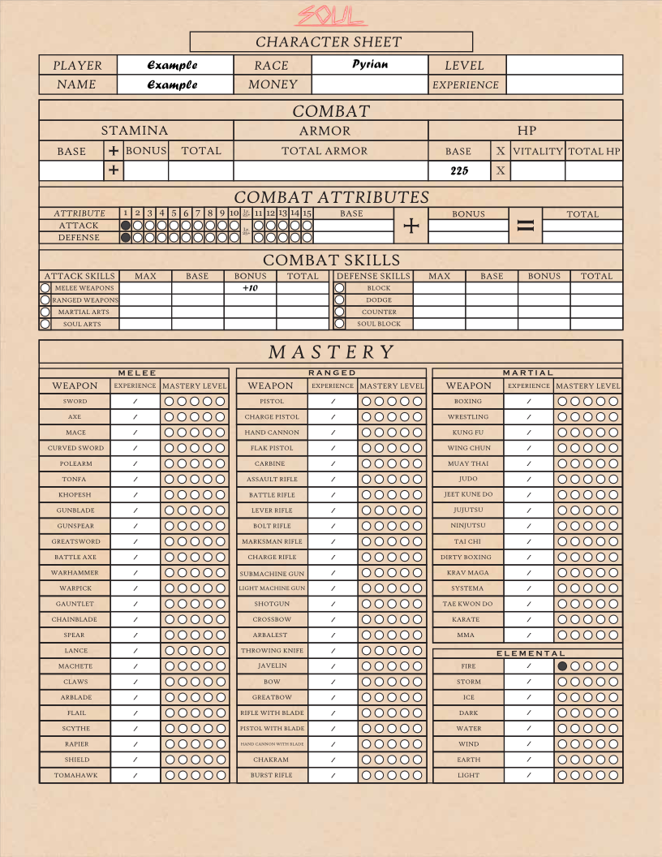

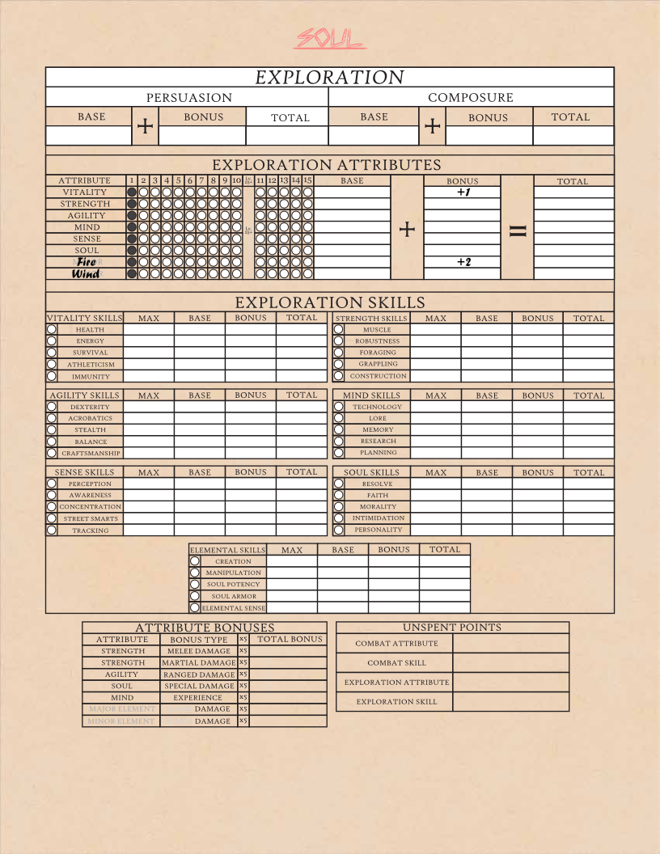

# Part 3: Assigning Attributes

Attributes are a character’s main stats. They are broad stats that represent raw aspects of a character, like their base intellect or their raw strength. Attributes, and the skills they govern, are divided into Combat and Exploration. This is so that it is easier to find what you need during gameplay, and to make keeping track of everything just a bit easier. Every Attribute other than your Major element will start at a value of 1.

Combat Attributes are Attack and Defense. Attack is used to attack enemies, and Defense is used to deflect or dodge incoming attacks.

In the combat attribute section, characters get 4 Attribute Points to distribute. Each point is worth 1 bubble. You may distribute these points however you wish by filling in the bubbles. The only condition is that no Attribute may exceed 4 bubbles when creating a character.

The bubbles represent your Base Attributes. Each bubble is another point toward that specific attribute. Once you have your four points in this section assigned, count your bubbles and put that number in the “Base” box to the right. After that, add any bonuses that appear in the “Bonus” box next to it, then, put the total in the “Total” box on the far-right side of the sheet. The “Total” box of an Attribute is the one that is used during combat or encounters, so it’s important to have it calculated correctly.

Remember, every attribute gets 1 bubble for free. The only way to have 0 in an attribute is through permanent negative bonuses.

Exploration Attributes are on the back of the sheet. You may notice that there are many more of these than there are the combat attributes. Each of them has a unique function during gameplay.

Vitality: Vitality represents a character’s physical fitness and health. It is multiplied by your base HP to determine your total HP. It is also used to resist poison, and for feats that test health directly

Strength: Strength represents a character’s raw strength. It is used for muscle, construction, foraging, grappling, and gives a small bonus to melee and martial art damage.

Agility: Agility represents skill with stealth, acrobatics, dexterity, and craftsmanship. It also gives a small damage bonus to ranged weapon damage.

Mind: Mind represents raw intellect. It is used for research, memory, planning, and to interact with tech. Characters gain an additional 5% experience for each level of mind they have, as well, up to 10.

Sense: Sense represents a character’s senses. Sight, smell, touch, hearing, balance, awareness. It is used for searching, tracking, and focus.

Soul: Soul represents personality and strength of spirit. It provides a small damage bonus to special attacks, and is used for persuasion, feats of willpower, intimidation, morality, and faith.

Major Element: This is a character’s main element. It is used for feats utilizing that element.

Minor Element: This is a character’s secondary element. It is used for feats involving that element.

The Exploration Attributes are just as important for roleplay as the Combat Attributes. These 8 attributes can be the difference between a deadly fight and a misunderstanding or can be the reason you found a shiny new sword instead of a pile of muddy coins.

Characters get 12 points to distribute among their Exploration Attributes when creating a character. The same rules apply here as did with the Combat Attributes, that being that you can assign these points wherever you wish, but no Attribute may start above 4 bubbles.

Once again, once you have finished assigning your bubbles, count them and put the corresponding values into the “Base” boxes next to them. Add or subtract any bonuses, then fill in the “Total” boxes on the right.

On the next pages, you will see an example of a sheet with all its attributes assigned.

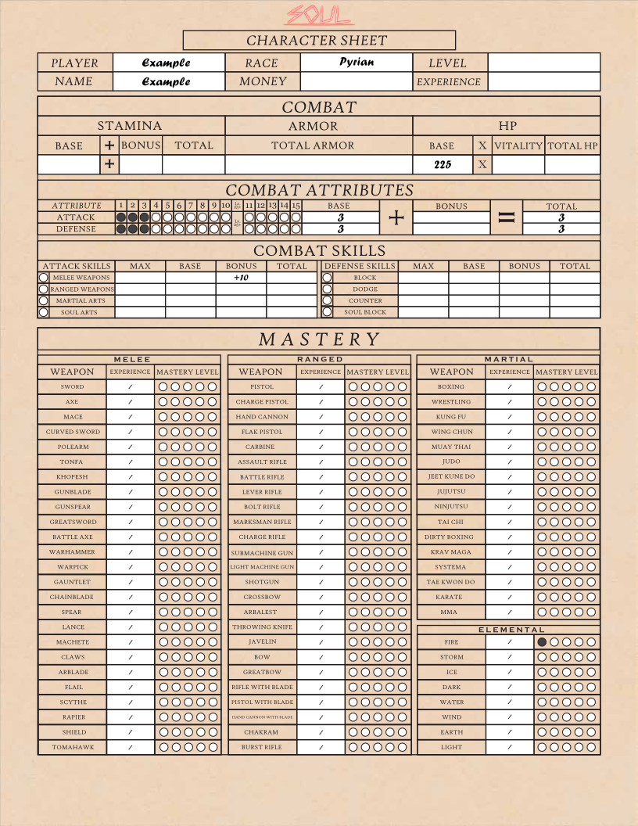

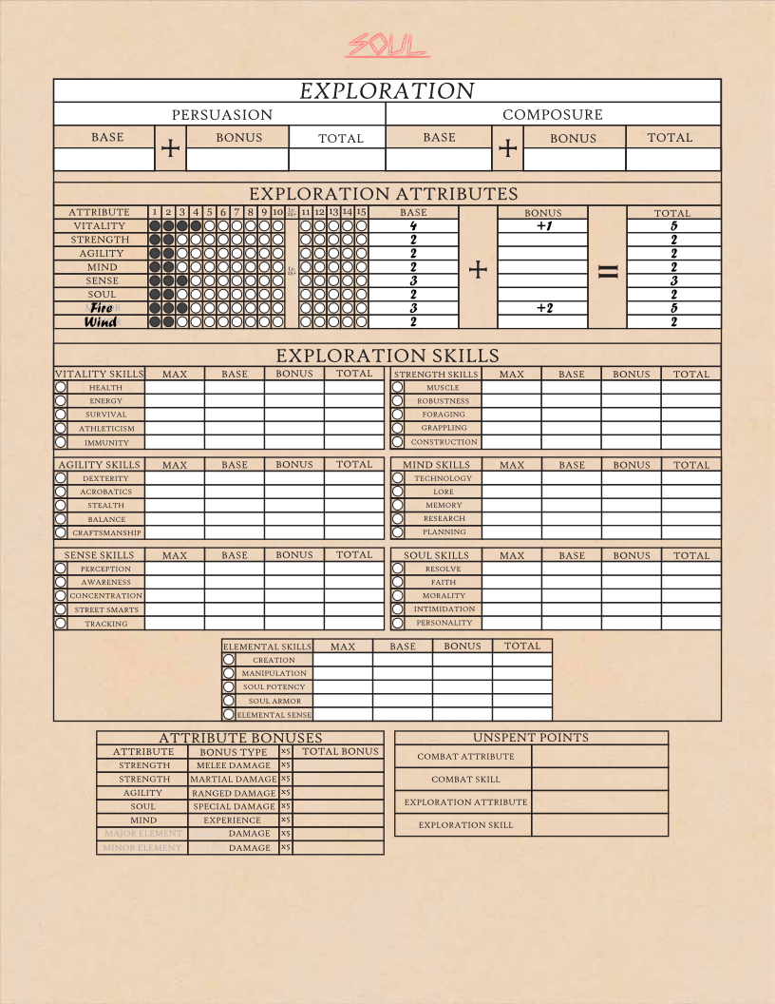

# Part 4: Skills and Talents

Skills are representations of broad practiced abilities that act as a base value for a roll. Each skill is governed by an attribute, which it is categorized under. That is the attribute that is used to roll for that skill. Skills have a minimum value of 5 and a maximum of 100. Every character has access to every skill, but they are not created equal. Characters can pick different talents to specialize in various areas.

Talents are special skills that are intrinsic to a character. Talents get a bonus to their starting value, their maximum value, and they level up with the player. Most of this section of the sheet is about determining what you’d like your character to specialize in and filling in all the corresponding values.

Skills are divided, like attributes, into combat and exploration. Combat skills are listed under the combat attributes on the combat side of the sheet. Exploration skills are listed below the exploration attributes on the Exploration side of the sheet. We will start in the combat section.

Looking at the combat skills, you’ll see they are divided into attack and defense, the two combat attributes. Under Attack, you’ll see melee weapons, ranged weapons, martial arts, and soul arts, and under Defense, dodge, block, counter, and soul block. Next to each skill is an empty bubble. Filling this bubble in indicates it as a talent. You may pick one attack talent, and one defense talent.

Once you have marked these talents, put a 15 in the base value, and a 125 in the maximum value. Add any bonuses that your character has, and then you can fill in the total value. Then, you may choose to fill in the rest of your combat skills with a base value of 5 and a maximum value of 100, add the bonuses, and mark the total.

You may also decide to “Buy” another talent. This costs 10 points from the maximum value of all your other combat skills, excluding the talents. This means you can fill in a third bubble wherever you like, and have three combat talents, but your combat skills will have a maximum value of 90.

Once you have your combat talents chosen, fill in your combat skills and flip the sheet over to the exploration side.

There are many more exploration skills than combat skills, as there are simply more attributes in this section. Each skill is named for its function, but there may be a few that are less obvious. These ones are listed below.

Research differs from Lore

Lore is existing knowledge of the world and its mechanics

Research is the ability to find and learn specific new information

Personality is effectively a character’s charisma

Intimidation is their ability to instill fear in others.

Resolve is a character’s willpower. It would be used if they are being tortured, for example, or if someone was attempting to intimidate them.

Faith is a character’s trust in a higher power. This could be a Christian faith, a dedication to the Sons of Cronus, or their immersion in the Machine religion of the Kalmarans. It could even be the strength of their belief in no power at all. It represents their knowledge of that faith as well, and their resistance to it being challenged.

Morality differs from faith as it is a representation of a character’s ability to adhere to their own moral code. If a character with a low morality is confronted with the strong urge to kill in anger or vengeance, they may fail, and strike in a situation that one with a higher morality would be able to stay their hand.

Creation is a character’s ability to conjure the elements in more complex ways before they become tired. A character with 10 creation may simply be able to conjure bolts of water or shoot arcs of electricity, but a character with 100 creation could call down bolts from the sky or summon a geyser from below their enemy.

Manipulation is a measure of someone’s ability to use their powers to manipulate existing objects. A character with 5 manipulation could barely lift a rock or create a small illusion, but those with 100 could raise a stout wall from the earth, change the temperature of their elements without changing their forms, or make themselves nearly invisible by redirecting light.

Soul Potency is the force that a character’s soul exerts on the world when using their powers. It is used to create objects within proximity to living things. The power over life was withheld from the Aeterni, and there is a strange field around living things that prevents them from being directly manipulated. Even the user is affected, though slightly less, and cannot, for example, circulate their blood normally or fill their lungs with air. As a result, it is incredibly difficult to conjure or manipulate anything directly in contact with someone else, and Soul Potency is used to do just that. If you want to grab someone’s leg with a rock to keep them from running or lower the density of the water around them to keep them from swimming, Soul Potency will be used.

Soul Armor is effectively a measure of the strength of that same field surrounding a character. Higher Soul Armor will potentially keep enemies from doing those same things mentioned above to you.

Elemental sense is a character’s ability to sense the elements they have been attuned to. Those with fire and wind can sense the presence of those elements in their proximity. The higher the skill, the more refined the sense.

Now that all of that is out of the way, it is time to allocate the exploration talents. In this category, just like the last one, you can pick one talent for each of the attributes. This doesn’t mean you have to have one talent under each one, but that you get to pick 7 total.

Like before, they start at a value of 15 and have a maximum of 125, and once you pick them you can total them up and fill in your other skills. You can buy up to two other talents for the exploration section. Each one will reduce the maximum value of the other skills by 10, though, so decide carefully if you believe it is worth it.

The skills and talents can be the most daunting aspect of the character sheet, but don’t worry. An example is once again included for reference on the next few pages.

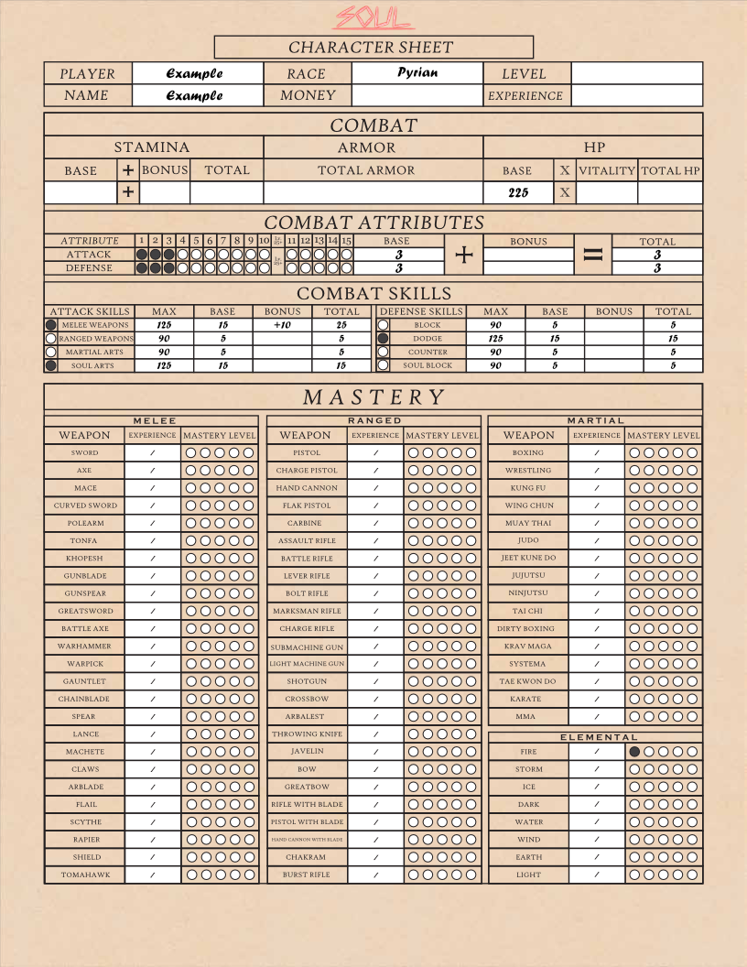

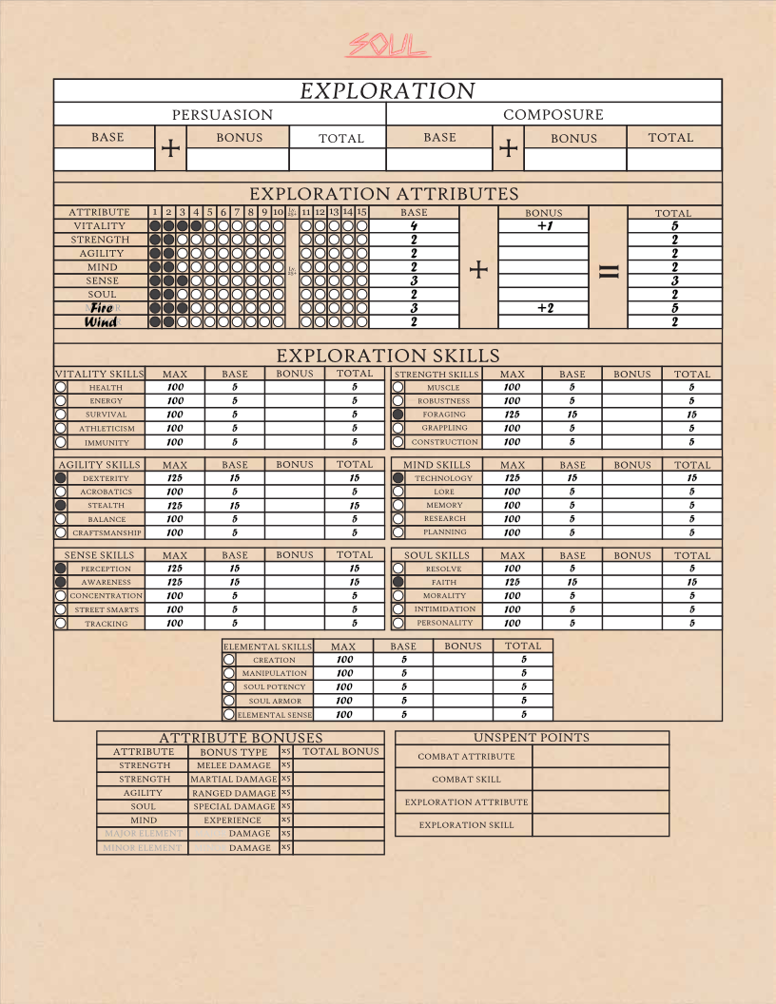

# Part 5: Mastery

Mastery is the last new piece of the puzzle before finishing up, and there isn’t much to it. Mastery is a mechanic that represents a character’s practical skill with various weapon types, martial arts, and their elements.

Every weapon class in soul as well as every element is included under the mastery section of the character sheet. They are divided into melee weapons, ranged weapons, and martial arts The elements are listed on the far right, but can be ignored until a bit later.

Mastery will give a character a bonus to their roll depending on its level whenever they use an attack with that weapon or element. Mastery levels up, just like the player, by gaining experience. After an encounter, any experience gained by the player will also be gained for each weapon or element they used during that encounter.

When creating a character, you may choose 4 total weapon classes from any of the different types, melee, ranged, or martial arts. Mark the first bubble on the left for each one you pick. This is level 1 mastery, meaning those chosen weapon classes get +1 when attacking.

From level 0 to level 1, 1000 experience is needed to level up a weapon or element. From 1-2, 2000, from 2-3, 3000, from 3-4, 4000, and from 4-5, 5000. You can fill in every weapon if you want, but for now, all that is recommended is that you put the experience you need next to the weapons that you have a level of mastery in. Once you’re done, your sheet should look something like this:

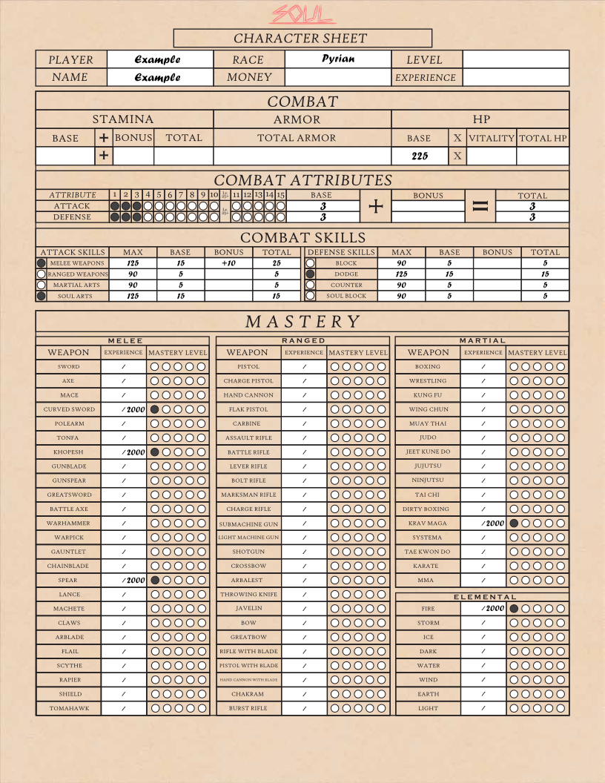

You may notice that the Fire element also has 1 bubble of mastery. That is because your major element always starts at a mastery level of 1. If your chosen race grants an additional bonus to mastery, it is a permanent bonus. It does fill in a bubble in this case.

# Part 6: Finishing the Character Sheet

The final step for the character sheet is to fill out the things that are still obviously missing. We will go over these one by one.

Level: Every character starts at level 0

Experience: It takes 1000 experience to level up from level 1 to 25.

Stamina: This is your stamina bar for combat. It always has a base of 100.

Armor: This will not be determined until you get your starting gear.

HP: This is whatever base value your race has for HP times your Vitality Attribute. For an Aeterni(200 base) with 3 Vitality, the total HP is 600.

Persuasion: This is calculated as Personality x Soul. It should be rounded to the nearest 10.

Composure: This is calculated as Memory x Mind. It should also be rounded to the nearest 10.

Attribute Bonuses: These are small bonuses granted to damage types depending on a character’s Attributes. They are calculated simply as (Attribute) x 5.

Once you’ve finished filling all of that out, your sheet should look something like this:

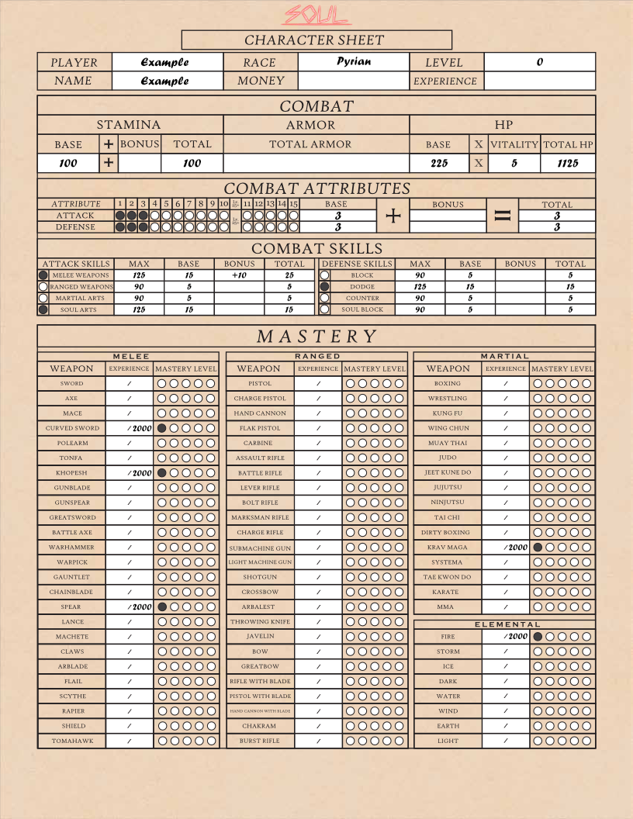

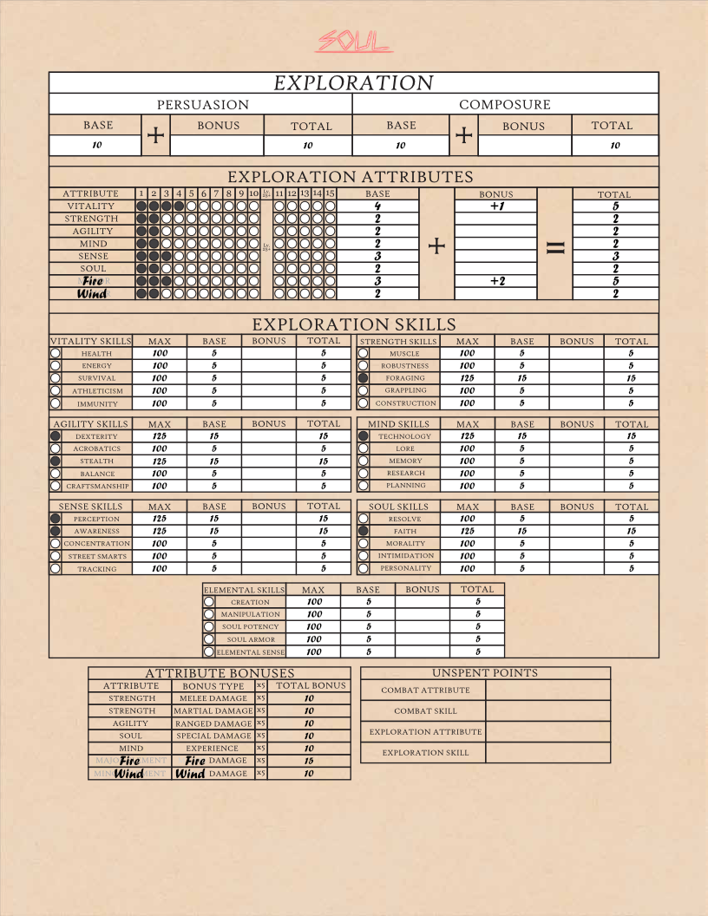

# Chapter 2: The Equipment Sheet

The equipment sheet is a sheet that contains all of the weapons and armor that a character is currently equipped with, as well as their inventory. It also lists a character’s cybernetics, should they have any installed.

For this section, you can pick a set of starting equipment and copy it into your equipment sheet. There are several to choose from.

|  |  |  |  |
| --- | --- | --- | --- |
| **Slot** | **Name** | **Armor** | **Bonus** |
| Helm | Bladesman’s Helm | 200 |  |
| Core | Bladesman’s Core | 300 | +1 Strength |
| Pauldrons(Left + Right) |  |  |  |
| Gauntlets(Left + Right) | Bladesman’s Gloves | 50 Each | +5 Melee Weapons Each |
| Greaves | Bladesman’s Greaves | 100 |  |

|  |  |  |  |
| --- | --- | --- | --- |
| **Slot** | **Name** | **Armor** | **Bonus** |
| Helm | Mk. 27 (B) Helm | 200 | +10 Ranged Weapons |
| Core | Mk. 27 Core | 300 | +1 Agility |
| Pauldrons(Left + Right) |  |  |  |
| Gauntlets(Left + Right) | Mk. 27 Gauntlets | 50 Each |  |
| Greaves | Mk. 27 Greaves | 100 |  |

|  |  |  |  |
| --- | --- | --- | --- |
| **Slot** | **Name** | **Armor** | **Bonus** |
| Helm | Wanderer’s Helm | 200 |  |
| Core | Wanderer’s Core | 300 | +1 Strength |
| Pauldrons(Left + Right) |  |  |  |
| Gauntlets(Left + Right) | Wanderer’s Gloves | 50 Each | +1 Martial Arts |
| Greaves | Wanderer’s Greaves | 100 |  |

|  |  |  |  |
| --- | --- | --- | --- |
| **Slot** | **Name** | **Armor** | **Bonus** |
| Helm | CLR1C Helm | 200 | +1 Soul |
| Core | CLR1C Core | 300 | +1 Soul Attack |
| Pauldrons(Left + Right) |  |  |  |
| Gauntlets(Left + Right) | CLR1C Gauntlets | 50 Each |  |
| Greaves | CLR1C Greaves | 100 |  |

Once you have chosen a set of equipment, you may copy it into the equipment sheet. Make sure to total up your armor and add it to the character sheet, as well as making any adjustments to stats from your armor’s bonuses.

Each character gets to pick one weapon to start with as well, but there is a much larger list of these, so they are contained in the companion book after the powers. It is recommended to pick one that matches your character’s elements and specializations, as that will allow you to make the most of your abilities. Weapons are individually as complex as the element’s powers, so they have a weapon sheet. This lists all of their attacks, shows you the damage and effects of each, and has a spot at the top for your attack rolls, so you can quickly check your attacks in battle. Your chosen weapon will simply be entered into the weapon sheet.

# Cybernetics

Cybernetics are mechanical enhancements to the body or body systems. The Kalmarans start with 1 Cybernetic Implant of their choice, so these are listed below.

|  |  |  |
| --- | --- | --- |
| Cybernetic | Slot | Effect |
| Sensory Tuner | Head | +5 Awareness |
| Hydraulic Muscle Reinforcer | Arms | +1 Strength |
| Supplementary Endoskeleton | Body | +100 Armor |
| Stabilizing Module | Legs | +5 Balance |

That’s it for character creation! Anything that you may need to reference can be found in the companion book, from weapons, to armor pieces, to all the powers, and the mechanics. All that’s left is to explore the world of Soul!